Wednesday
Lunchtime Concerts

providing music in the heart of the city since 1974
Aroha String Quartet International Music Academy 2022
13 07 22
Tutors' Concert
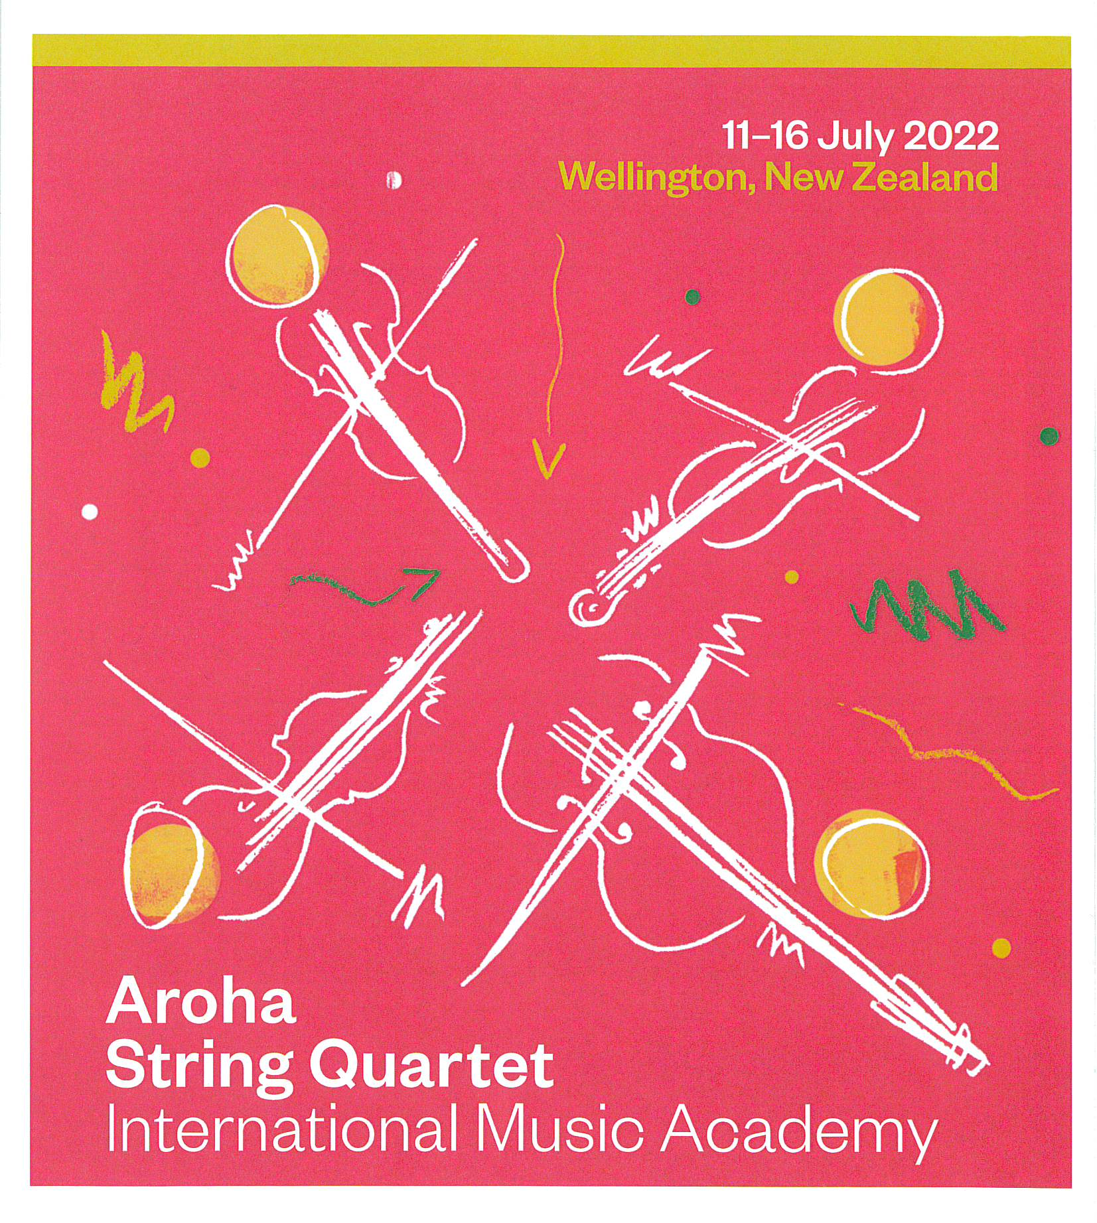
Welcome
It is wonderful that you have come. Thank you.
We want your experience today to be the best that it can be and would appreciate you taking a moment to read the following before the concert commences.
Keep safe by locating the exit nearest to your seat.
In the event of an earthquake, our recommendation is to Drop, Cover and Hold.
Bon appetit! You are welcome to have your lunch during the performance. Switching your cell phone to silent is important to the performers and other members of the audience.
Your support by way of a donation and telling others about the concerts would be fantastic and very much appreciated. It does make a difference.
If you wish to contribute by internet banking, our account is 020 534 000 4022 00.
Please put lunch concert in the particulars.
If you wish to photograph or video today’s concert, please ask for permission from the performer(s) before the concert begins. This is important.
We invite you now to sit back, relax and enjoy the concert.
Our Mission is to create a lively, open Christian faith community, to act for a just and peaceful world, and to be catalysts for discovery, compassion and celebration in the capital.
These lunchtime concerts are advertised through Radio New Zealand Concert’s Live Diary at around 8.10 am on the day of the concert, they are also advertised on Eventfinda, Dominion Post Arts Pages and Arts Wellington online, and listed on St Andrew’s website.
To be placed on the email circulation list for concert information, please email wednesday@standrews.org.nz. Also join our facebook group Friends of St Andrew's on The Terrace Lunchtime Concerts, https://www.facebook.com/groups/315497448862287/.
Check out the noticeboards in the foyer each time you come.

Programme
Wolfgang Amadeus Mozart (1756-1791)
String Quintet No 4 in G min K516, movement 4 (Allegro)

Haihong Liu - violin
Ursula Evans* - violin
Belinda Veitch* - viola
Zhongxian Jin - viola
David Chickering* - cello

Salina Fisher (1993-)
Mata-Au
Haihong Liu - violin
Zhongxian Jin - viola
Robert Ibell - cello

Valentin Silvestrov (1937-)
Postlude (arr. Gunchenko)

Oleksandr Gunchenko* - double bass
Donald Armstrong* - violin
Ursula Evans - violin
Sophia Acheson* - viola
Robert Ibell - cello

Felix Mendelssohn (1809-1847)
String Octet in E-flat Op 20, movement 1 (Allegro moderato ma con fuoco)

Haihong Liu - violin
Donald Armstrong - violin
Ursula Evans - violin
Zhongxian Jin - violin
Belinda Veitch - viola
Michael Cuncannon* - viola
Robert Ibell - cello
David Chickering - cello
Oleksandr Gunchenko - double bass

* = Guest tutor or guest player

This lunchtime concert is being given by members of the Aroha String Quartet, joined by guest tutors and guest players from the ASQ International Music Academy 2022.
The ASQ International Music Academy, now in its eighth year, is an annual string orchestra and chamber music course run by the Aroha String Quartet and the Academy Administrator, Cathie McCallum.
This year 37 non-professional string players from Invercargill to Adelaide via Whangarei, whose ages span about seven decades, have come to St Andrew's on the Terrace for six days of intensive rehearsals and coaching. The Academy will culminate in a participants' Gala Concert here in St Andrew's at 5 pm on Saturday 16 July. Join us again for some exciting music-making.
Aroha String Quartet, www.arohaquartet.co.nz, contact@arohaquartet.co.nz

Contact us
e | wednesday@standrews.org.nz p | 04-472-9211 w | www.standrews.org.nz
Coming Up

20 July - Family concert:
Carnival of the Animals by Saint-Saëns

27 July - VUW (Victoria University of Wellington) Piano Club

3 August - Douglas Mews – Baroque Organ

4 August (Thursday) - Classical voice students of the NZSM

Check out the What’s On and Concerts section on our website www.standrews.org.nz

