

Order of Service

2 August 2020

Pentecost 9

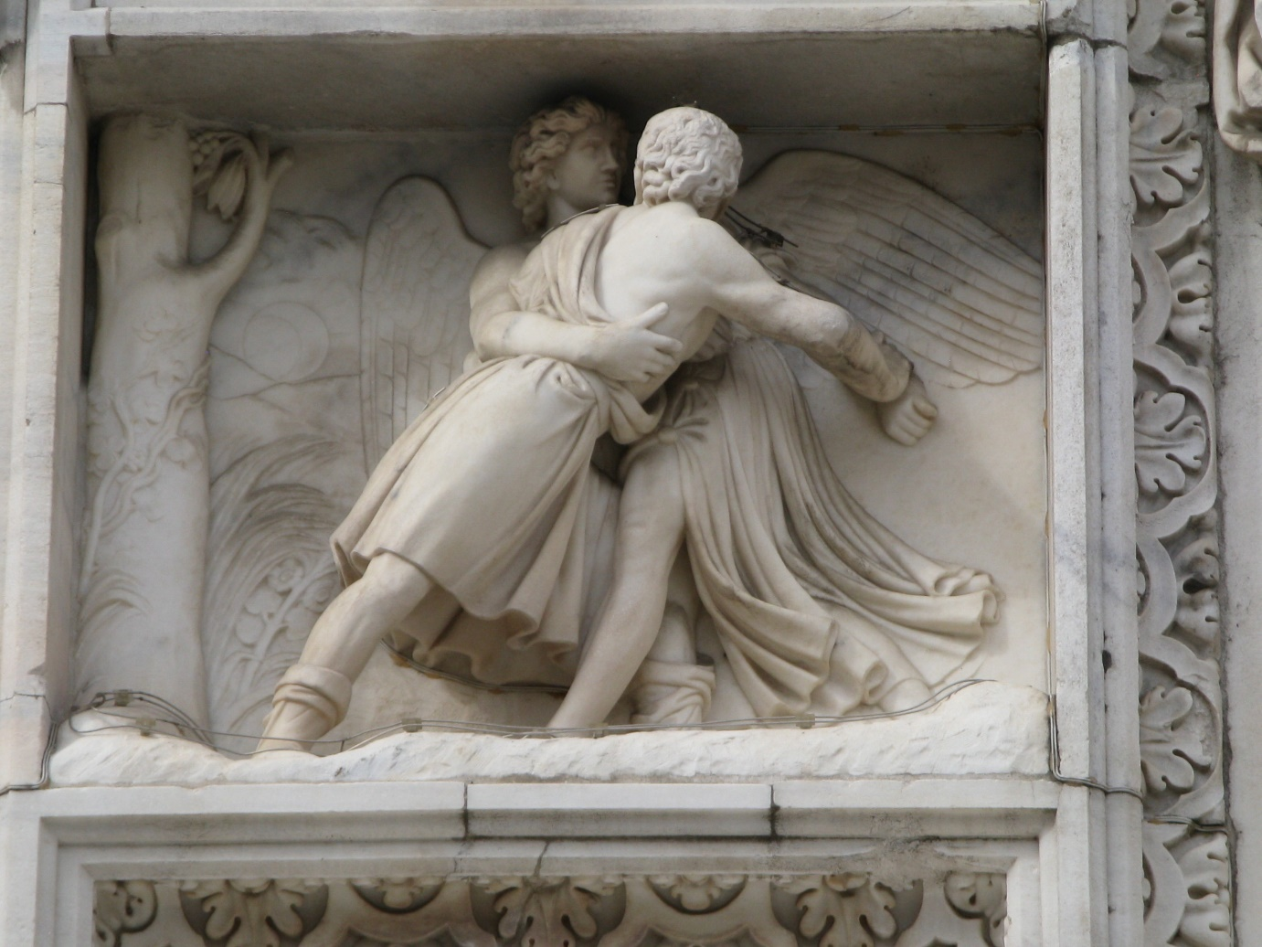

Wrestling Our Way to Wholeness

Welcome to St Andrew’s on The TerracE
Wherever you are on your faith journey,
wherever you have come from and wherever you are going to,
whatever you believe, whatever you do not believe, you are welcome here.
Please join in the congregational responses printed in bold italics.
Please stand if you are able, for the hymns and the offering prayer.
We usually sing the hymns without announcement.
To use the loop system in the church, turn your hearing aids on to the appropriate setting.
Printed copies of the reflection are available at the back of the church for people with extreme hearing loss. For others they can be picked up at the end of the Gathering.

Please note your nearest fire exit.
The church and hall have been earthquake strengthened. In an earthquake: drop, cover and hold.

Today’s service is led by Rev. Catriona Cairns

GATHERING Craig Mitchell (adapted)

Welcome to worship here
Whether you’re from Kāpiti, Khandallah, Newtown or the Hutt,
Whether you’ve been rushing this morning or started the day calmly,
Whether you have favourite seats or you’re here for the first time
Here, we can be community.

We are nine years old, twenty-nine and nearly ninety
We grew up with the wireless and wireless Internet
We love gardening and poetry, basketball and hip hop,
Here, we can be community.

We are straight and queer and all in-between
We are in all kinds of relationships, individual and together
We seek honest friendship and true belonging
Here, we can be community.

We have more questions than answers
We know what to expect, yet we have no idea
We have much hope and a little faith
Here, we can be community.

Let us worship together.

PROCESSIONAL HYMN FFS 10(i) ‘Come and find the quiet centre’
Words © 1992 Shirley Erena Murray
Music : Gaelic traditional melody arr. John Bell 3 verses
Come and find the quiet centre
in the crowded life lead,
find the room for hope to enter,
find the frame where we are freed:
clear the chaos and the clutter,
clear our eyes, that we can see
all the things that really matter,
be at peace, and simply be.

Silence is a friend who claims us,
cools the heat and slows the pace,
God it is who speaks and names us,
knows our being, touches base,
making space within our thinking,
lifting shades to show the sun,
raising courage when we're shrinking,
finding scope for faith begun.

In the Spirit let us travel,
open to each other's pain,
let our loves and fears unravel,
celebrate the space we gain:
there's a place for deepest dreaming,
there's a time for heart to care,
in the Spirit's lively scheming
there is always room to spare!

WELCOME
Kia ora tatou.
Kia ora.

OPENING PRAYER

JESUS’ PRAYER Jim Cotter paraphrase

Eternal Spirit
Life-Giver, Pain-Bearer, Love-Maker,
source of all that is and that shall be,
Father and Mother of us all,
loving God, in whom is heaven:
the hallowing of your name
echo through the universe!
The way of your justice be followed
by the peoples of the world!
Your heavenly will be done
by all created beings!
Your commonwealth of peace and freedom
sustain our hope and come on earth.
With the bread we need for today, feed us.
In the hurts we absorb from one another, forgive us.
In times of temptation and test,
strengthen us.
From trials too great to endure, spare us.
From the grip of all that is evil, free us.
For you reign in the glory
of the power that is love, now and for ever.
Amen.

LIGHTING THE RAINBOW CANDLE

TIME WITH THE CHILDREN Graham Howell

BLESSING THE CHILDREN (All stand)
We send you to the Rainbow Room to hear stories, ask questions and have fun together.
We bless you. Amen.

PASSING THE PEACE
Traditionally we shake hands to pass the peace and say “peace be with you”. The response is “peace be with you, or “and with you.” You can also simply say hello. Now that COVID-19 is here, we are all asked to take precautions again transmission. We invite you to try different methods of greeting each other. For example, place both hands together in the prayer position and bend head towards the other person, place a hand on one’s upper chest and a slight bow slightly to acknowledge the other. Feel free to simply observe if you wish.

THE WORD IN TEXTS Bronwyn White

Hebrew Bible: Genesis 32:22-31 ‘Jacob wrestles at Peniel’

Gospel: Matthew 14:13-21 ‘Feeding the five thousand’

Contemporary reading: From “The Velveteen Rabbit’ by Margery Williams

"What is REAL?" asked the Rabbit one day, when they were lying side by side near the nursery fender, before Nana came to tidy the room. "Does it mean having things that buzz inside you and a stick-out handle?"
"Real isn't how you are made," said the Skin Horse. "It's a thing that happens to you. When a child loves you for a long, long time, not just to play with, but REALLY loves you, then you become Real."
"Does it hurt?" asked the Rabbit.
"Sometimes," said the Skin Horse, for he was always truthful. "When you are Real you don't mind being hurt."
"Does it happen all at once, like being wound up," he asked, "or bit by bit?"
"It doesn't happen all at once," said the Skin Horse. "You become. It takes a long time. That's why it doesn't happen often to people who break easily, or have sharp edges, or who have to be carefully kept. Generally, by the time you are Real, most of your hair has been loved off, and your eyes drop out and you get loose in the joints and very shabby. But these things don't matter at all, because once you are Real you can't be ugly, except to people who don't understand."

RESPONSE
For the Word in scripture,
for the Word among us,
for the Word within us,
we give thanks.

REFLECTION ‘Wrestling our way to wholeness’ Rev. Catriona Cairns

OFFERING PRAYER (said together)
Like the disciples we sometimes feel we have little to offer, and that what we have won’t make a difference.
We bring our gifts and ourselves in the trust that together our intentions and energy will multiply, and bring justice and joy to others.
Amen

We recognise and bless the gifts brought to the table, and those which wing
their way electronically from our banks to the church’s account.

HISTORICAL HIGHLIGHT Lynette Burrell

LIFE IN THE COMMUNITY OF ST ANDREW’S
People share notices and visitors are welcomed. If you have a notice, please move to the front row, ready to speak briefly from the lectern.
For the benefit of newcomers, please introduce yourself before you begin.

PRAYERS OF THE PEOPLE Mike Wespel-Rose

CIRCLE OF PRAYER
We think today of the people of Belgium and Luxembourg and the United Protestant Church of Belgium. We remember the detainees of Manus and Nauru Islands, yearning that their cases be resolved. In New Zealand, we remember those in Parliament, and today we name Damien O'Connor (West Coast-Tasman electorate) and Greg O'Connor (Ōhāriu electorate). Here in the Central Presbytery, we pray for the leaders and people of St Andrew's Presbyterian Church, Hastings and from the worldwide church for the the Protestant Methodist Church of Benin.

PRAYER FOR ST ANDREW’S

Renew your people, God,
and renew our life in this place.
Give us a new spirit of unity
with those of all faiths,
and a new spirit of love
towards all people.

Bless the city in which we live
that it may be a place
where honest dealing,
good government,
the desire for beauty,
and the care for others flourish.

Bless this church
that what we know of your will
may become what we do,
and what we believe
the strong impulse
of our worship and work.

Amen

INVITATION TO COMMUNION
St Andrew’s is an open community and all are invited to Christ’s table.
Wherever you are on your faith journey, wherever you have come from and wherever you are going to, whatever you believe, whatever you do not believe, you are welcome to participate in the communion. This is God’s meal for all people.

COMMUNION HYMN FFS 17 ‘For everyone born, a place at the table’
Words: © 1998 Shirley Erena Murray
Music: © 1998 Colin Gibson (Hope Publishing) 5 verses

For everyone born, a place at the table,
for everyone born, clean water and bread,
a shelter, a space, a safe place for growing,
for everyone born, a star overhead,
and God will delight when we are creators
of justice and joy, compassion and peace:
yes, God will delight when we are creators
of justice, justice and joy!

For woman and man, a place at the table,
revising the roles, deciding the share,
with wisdom and grace, dividing the power,
for woman and man, a system that's fair,
and God will delight when we are creators
of justice and joy, compassion and peace:
yes, God will delight when we are creators
of justice, justice and joy!

For young and for old, a place at the table,
a voice to be heard, a part in the song,
the hands of a child in hands that are wrinkled,
for young and for old, the right to belong,
and God will delight when we are creators
of justice and joy, compassion and peace:
yes, God will delight when we are creators
of justice, justice and joy!

For gay and for straight, a place at the table,
a covenant shared, a welcoming space,
a rainbow of race and gender and colour,
for gay and for straight, the chalice of grace,
and God will delight when we are creators
of justice and joy, compassion and peace:
yes, God will delight when we are creators
of justice, justice and joy!

For everyone born, a place at the table,
to live without fear, and simply to be,
to work, to speak out, to witness and worship,
for everyone born, the right to be free,
and God will delight when we are creators
of justice and joy, compassion and peace:
yes, God will delight when we are creators
of justice, justice and joy!

COMMUNION LITURGY Rex A E Hunt (adapted)

Welcome to the Table...
At this table we give thanks for justice, love, peace and freedom.
At this table we give thanks for friends and strangers
together in community in this safe place.
At this table we welcome old and young.
A place at the table.
And all are invited.

We give thanks for the unfolding of matter,
mind, intelligence, and life
that has brought us to this moment in time.
We celebrate our common origin with everything that exists.
We celebrate the mystery we experience and address as ‘God’,
ground and sustainer of everything that exists,
in whom we live and move and have our being.
And we acknowledge this mystery embodied
in every human person,
aware that each one of us gives God
unique and personal expression.
God is everywhere present.
In grace-filled moments of sharing.
In carefully created communities of loving solidarity.
We are one with everything, living and nonliving, on this planet.
Connected.
Interrelated.
Interdependent.

We remember the stories from our tradition...
How on many occasions Jesus would share a meal with friends.
Bread and wine, the very basics of life, shared in community.
For everyone born, a place at the table...
How the bread would be taken,
a blessing offered, and then shared between them.
And all of them ate.
How some wine would be poured out,
a blessing offered, and then passed between them.
And all of them drank.
A time of concern, conversation and celebration.
The bread and the wine symbolised human lives
interconnected with other human lives,
and the power of giving and receiving.
For everyone born, a place at the table...
This is the cup of peace and of new life for all.
A sign of love for the community of hope.
A reminder of the call to live fully,
to love wastefully, and
to be all that we can be.

You are invited to come to the front of the church and receive the wine, or grape juice, and then the bread, or a gluten-free cracker.
Or, remain in your seat to be served if mobility is difficult.
If you don't wish to receive communion, please remain in your seat – we’re glad you are here with us.

We give thanks that we have
gathered together in this sacred place,
and been refreshed at this table.
We rejoice in the wholeness of each person here.
We are grateful for who we are for each other.
May we go forth into the world in courage and peace.

HYMN FFS 14 ‘Faith has set us on a journey’
Tune: Austria WOV 374(1) Words: Shirley Murray © 3 verses

Faith has set us on a journey
past the landmarks that we know,
taking risks with no insurance
but the Word that tells us "go!"
Friend or job or home or lover
we may need to leave behind,
outworn truths and ways of thinking,
baggage to the past consigned.

Some are swags of easy conscience
who with others hitch a ride,
some are tourist-package Christians,
dollar-safe, with Book and guide.
There are others on this journey --
those who long and pray and search,
heave the stones to free the structures,
love the Christ and leave the Church.

We are this unlikely people
in the Body knit as one,
company of clowns and cripples --
some are wise and some can run.
Prophets are our travel agents,
gospel-makers lay this road:
to the place of peace and promise
faith will take us into God.

BLESSING
We go from this place into our week
Changed, a seed of transformation planted deep within us,
So in our conversations and actions, thoughts and dreams,
May we know more deeply the presence we call God,
Soothing and disturbing us,
A blessing to make us whole.

SUNG AMEN

POSTLUDE Prelude in C major (BWV 553) by J.S. Bach (1685 – 1750)

THANK YOU Thank you to Peter Franklin
our musician today
Unless otherwise specified all our music is used by permission CCLI Licence 341550
Words/music to new hymns and gathering statement, prayers and affirmation are original unless acknowledged.

AUDIO REFLECTIONS
Sunday reflections are usually available on our website.
http://www.standrews.org.nz/category/sunday-gathering

Wellington City Council now charges for weekend parking on the street. As well as that, there is a two hour parking limit. If you have parked on the street initially and are staying for an after-church activity,
it may be possible to move your car into the St Andrew’s/Braemar car park but please be careful that you do not block anyone in, and do not park in carparks No.s 14, 19 & 20.

We welcome all visitors and invite you to stay for morning tea or coffee.
Please sign the visitors’ book at the back of the church.
We hope you enjoyed worshipping with us. At St Andrew’s we want you to feel at home—to join in with the activities of our community of faith, or to come and find your own spiritual place in your own time. If you would like more information about St Andrew’s or to explore becoming a member or associate member, please fill in one of the welcome leaflets (at the back of the church) and hand it to a minister or a welcoming team member.
GENEROUS GIVING
St Andrew’s depends on the generous giving of members and friends.
If you would like to make a donation or support our work through planned giving, please contact our Parish Office or Treasurer. Bank account for donations is: St Andrews on The Terrace, BNZ Lambton Quay, 02-0534-0004022-02

ST ANDREW’S COMMUNITY NOTICES

FUNDRAISER FOR THE ORGAN
The sale of jams and jellies, chutney and lime cordial raised $352. There were a few jars over, if you missed out and they will be put on sale at morning tea in a month or two. Maxine Cunningham

AVAILABILITY FOR ROSTERS FOR SEPTEMBER TO NOVEMBER
A reminder for those who help on our rosters that we will be putting together a new roster for the period September to November shortly. If you have any dates during this period that you know you will be away please notify the office by Tuesday 4th August office@standrews.org.nz. Thank you. N.B. Please reply with a quick “ available throughout” if you have no away dates, so we don’t include you in the “hasn’t replied” list who may need reminding. Thank you Jillene and Rosemary

SPIRITED CONVERSATIONS
To be held Tuesday, 4 August with a meal at 6.15 and speaker at 7.
Our speaker will share his experiences of being in a Korean religious movement as a 20 year old and his reflections after more than 10 years out. We’ll be asking for a contribution of $10 each towards the meal and towards a gift for the speaker.
From next Sunday we’ll be collecting names of those coming after church or you can contact Tony on tony@thekirbys.co.nz.
Thanks to our helpers and to the people who attended a fun and informative session with Marlon Drake this month.

NOTICE OF SPECIAL GENERAL MEETING SUNDAY 9 AUGUST 2020 11:45 AM
There will be a Special General Meeting on the above date to consider and approve the model of ministry and terms of call for a new Minister to assist the work the Ministry Settlement Board for St Andrew’s on The Terrace.
Paul Barber, Treasurer will also present the revised Budget for 2021 in light of
COVID-19.
Lynne Dovey, Parish Council Convenor


SATRS ANNUAL GENERAL MEETING
Friday August 7th, 2020 at 6.30pm, in Conference Rooms 1 & 2
on the first floor of the St Andrews Centre.

The evening will begin with a light meal, followed by the Annual General Meeting and conclude with a reflection by the Rev. Jim Cunningham,
“On / From the Mountain-top?”

LIBRARY MATTERS
Hello everybody
Now that morning tea will be in the hall more often, we need to think about the library. What I propose for now is that the library will be opened by the rostered “library monitor” for 10 minutes before the service and about 15 minutes after church each Sunday.
People who wish to browse, borrow or return books can do so during this time.
I hope this suits everybody including our library volunteers.
Thanks, Mike Wespel-Rose

AMNESTY INTERNATIONAL NEWS
On Sunday August 9th we have a congregational lunch after church. At this time we will have an Amnesty letter writing table set up in the corner of the hall.
Hopefully you might find time to write a letter on behalf of a person being persecuted unjustly. These letter writing campaigns can help. But also they are taking a stand for what is RIGHT.
At the table we will have copies of case studies and letter writing materials as well as guide letters for a variety of “prisoners of conscience”.
If you wish to contemplate or even prepare/write a letter before the Sunday meeting you can visit the following link and make a choice yourself.

https://www.amnesty.org/en/latest/campaigns/

When you choose a particular campaign, you will need to down load the pdf. (click the button).
At the end of that pdf there will be a date indicating when correspondence should be completed by. Please check this.
Completed letters will be sent to the Amnesty office in Auckland who then post them on to the relevant governments.
Thanks for taking an interest in this human rights activity.
Mike Wespel-Rose and John Morgan

BRAZIL
Antonio Lima has sent on this letter from a human rights activist/ theologian re the situation in Brazil, asking for it to be circulated:.
https://www.brasilwire.com/frei-betto-a-genocide-is-taking-place-in-brazil/ Many thanks, Trish

HEALTH AND SAFETY CAN YOU HELP?
In our Health and Safety planning it would be good to know if we have medically trained personnel in our congregation, or trained first aiders, happy to be called on if needed during Sunday Gatherings and other church events. We would be discreet about such a list, but if leaders of a church event know who is qualified they can more rapidly turn to those people first. Of course in a city like Wellington we would very quickly ask for ambulance aid, but it is good to know who is trained in what to do initially. Please let Pam Fuller know if you are one of these people.

WIDER CHURCH AND COMMUNITY NOTICES

UPCOMING PUBLIC LECTURES
Flourishing Futures: Theological Conversations on Important Issues

Tuesday 11 August, 7.30pm
Ramsey House, 8 Kelburn Parade, Kelburn, Wellington
Hovels, havens and homes: Just housing and health communities’
We enthusiastically sing Dave Dobbyn’s de-facto national anthem, ‘Welcome Home’, but how can our homes be places of welcome when many are old, cold, damp, and overcrowded? Is home ownership still a realistic aspiration? Is it possible to reconstruct our society for more equitable housing outcomes? To what extent might the Christian tradition offer new ways of responding to these questions – both conceptually and practically?
Come along to hear how people’s faith motivates them to explore creative house-design, new patterns of living, and innovative policy as responses to New Zealand’s housing crisis.
Panelists:
- Charles Waldegrave – Family Centre Social Policy Research Unit
- Kate Day – Advocacy Enabler, Wellington Anglican Diocese
- Wayne Kirkland – Managing Trustee, Koinonia Community Housing Trust
- Danielle Webb – Catholic Worker Movement, Berrigan House.
For further details, contact: andrew.shepherd@otago.ac.nz

Tuesday 25 August, 7.30pm
Ramsey House, 8 Kelburn Parade, Kelburn, Wellington
Students, Citizens & Surveillance: Technology, Theology & the Future of Education and Democracy’
Digital technology is ubiquitous – tracking our movements, recording our consumer purchases, and now utilised extensively in our classrooms. What is the future for education in the time of Facebook? How does the phenomenon of social media deepen or diminish the concept of education for citizenship? What are the new possibilities and pitfalls posed to democracy in this brave new world? In the Judeo-Christian Scriptures, God is referred to as the one who “sees” the plight of the vulnerable (Gen 16:13). To what extent can digital technologies be utilised for the benefit of those marginalised within our society? This panel brings together a variety of perspectives on these questions from within the Christian tradition, with the aim of re-framing our understandings of technology, education, and citizenship, and stimulating deeper thinking about how we might live well in an age of “surveillance capitalism.”
Panelists:
- Dr Bronwyn Wood – Senior Lecturer, School of Education, VUW.
- Adi Leason – Waihopai saboteur
- Matthew Bartlett – Executive Director or Citizen AI
For further details, contact: andrew.shepherd@otago.ac.nz.

MARY POTTER HOSPICE STREET COLLECTION – 18th and 19th September
All the money raised at the Appeal will be used to help us keep our services free-of-charge for anyone that may need us. If you can help us by volunteering at this year’s street collection, please register your support on our website https://marypotter.org.nz/events/street-appeal/

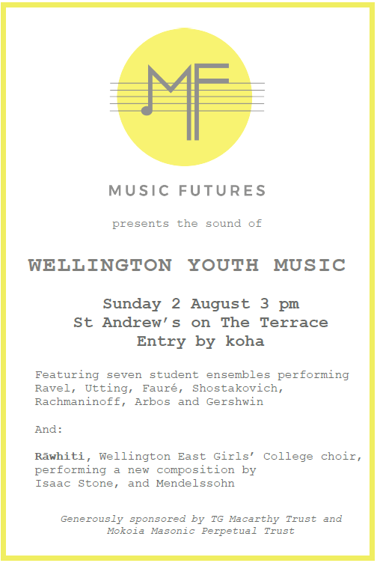 | The Community of St Luke  Remuera-Newmarket Community Centre  RESCUING THE BIBLE FROM FUNDAMENTALISM  By John Shelby Spong  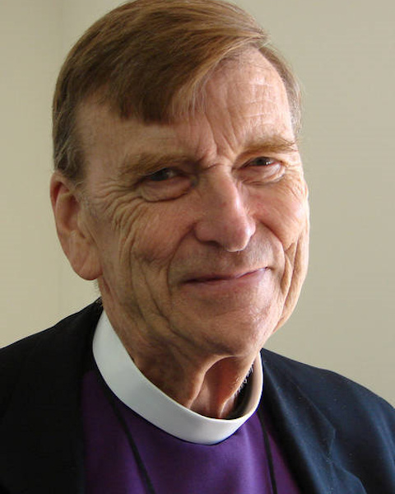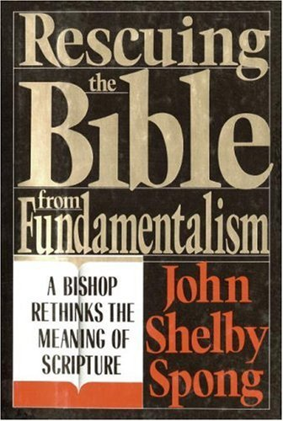  A study group led by Rev Glynn Cardy via a series of four Zoom meetings  Tuesday evenings at 7.30pm on 4, 11, 18 August and 1 September  NOTE: The Zoom link will be sent to all registered participants the day before each meeting  Cost: $10 for the series  Registration: stlukes.org.nz/events | pamela@stlukes.org.nz | 09 520 0740

SUNDAY ROSTERS
A folder with an outline of each duty is now kept on the back table. If you are unable to do your rostered duty please arrange a swap/substitute and inform the office. Thank you.
Thanks to this week’s volunteers
Welcoming | Fiona McDougal, Patricia Booth
Sound | Tony Cowdry
Laptop | Cameron Smart
Offering | Joan Tyler, Katrina Harper
Coffee/tea | Laura and Melissa Van Echten, Richard Owen
Time with the Children | Graham Howell
Readings | Bronwyn White
Prayers of the People | Mike Wespel-Rose
Communion | Frank Cook, Kath Kerr, Linda Wilkins, Margaret Pannett, Norman Wilkins
Rainbow Room Helper | Graham Howell
Library | Gillian Feist
Musician | Peter Franklin

On duty Sunday 9 August
Welcoming | Brian and Lynette Burrell
Sound | Tony Cowdry
Laptop | Sonia Groes Petrie
Offering | Graham Howell, James Cone
Coffee/tea/lunch | Katrina Harper, Linda and Norman Wilkins, Pam Fuller
Time with the Children | Cameron Smart
Readings | Jim Cunningham
Prayers of the People | Lynne Dovey
Rainbow Room Helper | Sandra Kirby
Library | Trish McBride
Musician | Bruce Corkill

This Week and Coming Events at St Andrew’s
Sunday 2 August 10am Sunday Communion Service led by Rev. Catriona Cairns
followed by congregational conversation.
Wednesday 5 August:
10.30am - Cuppa and a Chat in the Centre
11:45am - A slice of silence – Wednesday lunchtime zoom
Gathering at 1145 Followed by Centering Prayer and Farewells - Zoom address https://zoom.us/j/98632944617?pwd=cmk3MHUwcUQxalQ0Vy9vR0swZHp3QT09
12:15pm Wednesday Lunchtime Concert – Liam Furey (piano) Music by Schoenberg; Schumann, and Liam Furey.
Sunday 9 August 10am Sunday Gathering led by Rev. Reg Weeks
followed by Congregational Brunch in the Hall

MISSION STATEMENT OF ST ANDREW'S ON THE TERRACE

To create a lively, open Christian faith community,
to act for a just and peaceful world, and to be catalysts for discovery,
compassion and celebration in the capital.

MINISTRY AT ST ANDREW’S – THE TEAM
Interim Moderator | Catriona Cairns
Parish Council Convenor | Lynne Dovey
Treasurer | Paul Barber
Facilities Management Group | Sandra Kirby
Pastoral Care Coordinator | Linda Wilkins
Church Music Coordinator | Mark Stamper
Theologian in Residence | Lloyd Geering
Presbytery Representative | Lois Robertson
Concert Coordinator | Marjan van Waardenberg
Faith in Action Co-ordinator | Margaret Rushbrook
Rainbow Room Coordinator | Jules Collinson
Centre Manager | Laetitia Brunell
Office Administrator | Jillene Everett
Facilities Assistants | Claudia Monkhouse and Kate Crichton
Roster Coordinator | Rosemary Lawrence

St Andrew’s on The Terrace
www.standrews.org.nz
30 The Terrace – P O Box 5203, Wellington 6145
Office Hours: 9 am – 5 pm Monday to Friday


Phone (04) 472-9211
office@standrews.org.nz

Interim Moderator – Rev. Catriona Cairns
catrionajcairns@gmail.com, Cell: 0273059129

