

Order of Service

19 April 2020

Posted at www.standrews.org.nz only

Easter 2



Photo: © 2019 Niki Francis

Welcome to St Andrew’s on The TerracE
Wherever you are on your faith journey,
wherever you have come from and wherever you are going to,
whatever you believe, whatever you do not believe, you are welcome here.

This Service is conducted by Rev Dr Niki Francis

Introduction: Catriona Cairns

GATHERING
We gather here as people connected with one another
through our humanity,
interwoven threads in life’s web.

We come to hear stories that might help us navigate
the challenges before us
and encourage us to be kind
to each other and ourselves
as we travel in the shadow of Covid-19.

As we gather, we remember that we are not alone:
we are part of this community
founded on the stories of the man Jesus,
the one who told us to love one another.
Let us walk together now for this little while
and remember the love and support our community offers.
Amen

PROCESSIONAL HYMN ‘Simple Gifts
Words and Music: Simple Gifts. Joseph Brackett Jr. (Public domain)
played by Mark Stamper

'Tis the gift to be simple, 'tis the gift to be free,
Tis the gift to come down where we ought to be,
And when we find ourselves in the place just right,
'Twill be in the valley of love and delight.
When true simplicity is gain'd,
To bow and to bend we will not be asham'd,
To turn, turn will be our delight,
Till by turning, turning we come round right.

WELCOME AND OPENING
Kia ora tatou.
Kia ora.

PRAYER
Spirit of love, we gather today in our different places,
apart physically, but together in spirit.
In the spirit of love we meet in community
to support and nurture each other
that we may seek justice, hope and truth.
We are thankful
for the times we share with each other in this way
for our sense of belonging
for this community
that enables us to reach out
and share love and kindness with others around us.
Amen

JESUS’ PRAYER

Eternal Spirit
Life-Giver, Pain-Bearer, Love-Maker,
source of all that is and that shall be,
Father and Mother of us all,
loving God, in whom is heaven:
the hallowing of your name
echo through the universe!
The way of your justice be followed
by the peoples of the world!
Your heavenly will be done
by all created beings!
Your commonwealth of peace and freedom
sustain our hope and come on earth.
With the bread we need for today, feed us.
In the hurts we absorb from one another, forgive us.
In times of temptation and test,
strengthen us.
From trials too great to endure, spare us.
From the grip of all that is evil, free us.
For you reign in the glory
of the power that is love, now and for ever.
Amen.
LIGHTING THE RAINBOW ROOM CANDLE

PASSING THE PEACE
(We invite you to take this moment to greet those who are with you today, or to hold in your mind others from St Andrew’s, or your own loved ones)

THE WORD IN TEXTS Jennifer Bush

Gospel John 20: 19-31

Contemporary reading “Wild Geese”
by Mary Oliver
From: New and Selected Poems, Beacon Press, Boston, 1992.

You do not have to be good.
You do not have to walk on your knees
for a hundred miles through the desert, repenting.
You only have to let the soft animal of your body
love what it loves.
Tell me about despair, yours, and I will tell you mine.
Meanwhile the world goes on.
Meanwhile the sun and the clear pebbles of the rain
are moving across the landscapes,
over the prairies and the deep trees,
the mountains and the rivers.
Meanwhile the wild geese, high in the clean blue air,
are heading home again.
Whoever you are, no matter how lonely,
the world offers itself to your imagination,
calls to you like the wild geese, harsh and exciting–
over and over announcing your place
in the family of things.

RESPONSE
For the Word in scripture,
for the Word among us,
for the Word within us,
we give thanks.

REFLECTION Niki Francis

HYMN Deep truths to find
Words ©2018 Fiona McDougal (from the St Andrew’s collection)
Music: Tallis’ Canon played by Peter Franklin (public domain) WOV 468

The gospel writers tell the tale
of Jesus’ suffering and death,
each with a diff’rent emphasis
enhancing meaning, truth and depth.

For Matthew Jesus is Messiah,
fulfilment of the scriptures, come.
For Mark, he is self-giving way,
the path he walks and leads us on.

In Luke he dies to end oppress’n,
unjustly killed, a martyrs’ woe
and John sees Jesus lifted up,
his death a seed, new fruit to grow.

We’ve deconstructed, questioned, raged,
but theories mystery can’t define.
So now we move beyond that place
with open hearts deep truths to find.

OFFERING PRAYER
In the spirit of love, compassion and justice
we ponder our gifts
whatever they be
and however small,
and we commit to sharing what we can
in love, kindness and generosity.
Amen

We recognise and bless the gifts brought to the table, and those which wing
their way electronically from our banks to the church’s account.

PRAYERS OF THE PEOPLE Catriona Cairns

CIRCLE OF PRAYER
We think today of the people of Afghanistan and all those working towards peace in Afghanistan. We remember the detainees of Manus and Nauru Islands, yearning that their cases be resolved. In New Zealand, we remember those in Parliament, and today we name Agnes Loheni and Marja Lubeck list MPs. Here in the Central Presbytery, we pray for the leaders and people of Bulls/Turakina Presbyterian Parish.

PRAYER FOR ST ANDREW’S

Renew your people, God,
and renew our life in this place.
Give us a new spirit of unity
with those of all faiths,
and a new spirit of love
towards all people.

Bless the city in which we live
that it may be a place
where honest dealing,
good government,
the desire for beauty,
and the care for others flourish.

Bless this church
that what we know of your will
may become what we do,
and what we believe
the strong impulse
of our worship and work.

Amen

MUSIC ‘Bridge Over Troubled Water’
Words and music: 1970 Simon and Garfunkel
Arranged: Håkan Sund

We hope you enjoy this recording of Simon and Garfunkel’s “Bridge Over Troubled Water” recorded by the Wellington College Chorale, Wellington College, Wellington, Aotearoa New Zealand.

BLESSING
May you be filled with the spirit of hope
Challenged by the spirit of justice
Strengthened by the spirit of community
Opened by the spirit of generosity
Wrapped in the spirit of love.
I wish you peace.
Kia tau te rangimarie ki a koe.
Amen

TIME FOR A CUPPA

The end of our Sunday service is normally a time for catching up, meeting people and sharing what is happening in our lives. Perhaps you would like to phone a St Andrew’s person today.

THANK YOU
Mark Stamper, Wellington College Chorale and Peter Franklin
Our musicians today

Unless otherwise specified all our music is used by permission CCLI Licence 341550
Words/music to new hymns and gathering statement, prayers and affirmation are original unless acknowledged.

AUDIO REFLECTIONS
Sunday reflections are usually available on our website.
http://www.standrews.org.nz/category/sunday-gathering

GENEROUS GIVING
St Andrew’s depends on the generous giving of members and friends. If you would like to make a donation or support our work through planned giving, please contact our Parish Office or Treasurer. Bank account for donations is: St Andrews on The Terrace, BNZ Lambton Qy, 02-0534-0004022-02

ST ANDREW’S COMMUNITY NOTICES

GIVING TO ST ANDREW’S ON THE TERRACE FOR ONGOING MINISTRY

During COVID Alert Levels 3 and 4 the St Andrew’s Centre is unable to operate. The closure of the Centre has resulted in a significant loss of income and this means we are more reliant than ever on planned giving to support our ministry. As you know we are doing this in a new way by going online with our weekly services. We are delighted that our videos on YouTube are receiving between 250 and 350 views each week.

If you do not already have a weekly automatic payment you may like to set one up or you can make a donation to help us manage through this time. Thank you.

Our bank account number is: 02 0534 0004022 02

GIVING TO THOSE IN NEED

DOWNTOWN COMMUNITY MINISTRY
A reminder for those who shop at Chaffers New World on 279 Wakefield Street, that Downtown Community Ministry have a dropbox there for the food bank.

You can also make a donation to DCM. Their bank account is 03 0558 0060344 00. Thank you.

To read more news from DCM, please click the link to access their latest update:
https://mcusercontent.com/979e71a3c71a4a2e800e1794a/files/e56b319f-57a9-439e-9807-415b00201fb6/COVID_19_DCM_How_you_can_help.pdf

GLENVIEW PRIMARY SCHOOL COMMUNITY - CANNONS CREEK

A particular community in need that has come to our attention is the predominantly Pacific Island community in Cannons Creek. The Principal of Glenview Primary School there, Lynda Knight-de Blois, is providing emergency food boxes for her school community and would very much appreciate donations online.

Lynda writes: 'Families can get a one-off Covid19 Whanau Ora package from a couple of Porirua NGOs. However this comes in the form of supermarket vouchers and there is no supermarket in Cannons Creek. For families who find it hard to get over to Porirua City (e.g single parents or caregivers with small children, or no car), things are not easy at the moment’.

The Glenview School bank account details are: 12-3254-0146134-00 Visa Debit Account. Please put Food Hamper in the reference line and perhaps identify yourself as St Andrew’s on The Terrace.

CENTRAL PRESBYTERY NEWS
This week’s Central Presbytery news can be found by clicking the following link:
http://presbyterycentral.org.nz/images/docs/Roundup/20200408_Central_Roundup.pdf

PRAYERS FOR COMMUNITY IN A TIME OF PANDEMIC
The Corymeela Community are posting a prayer each day during this time.
They are beautiful- have a look.
https://www.corrymeela.org/news/180/prayers-for-community-in-a

WIDER CHURCH AND COMMUNITY NOTICES

PEACE AOTEAROA
Information about the Local Peace Grants and the application form are online at http://www.converge.org.nz/pma/lpg.htm Share this reminder on Facebook at https://www.facebook.com/PeaceMovementAotearoa/posts/2850162915031059.
Information about Quakers is available at http://www.quaker.org.nz - please note that the Local Peace Grants details have not yet been updated on that website.

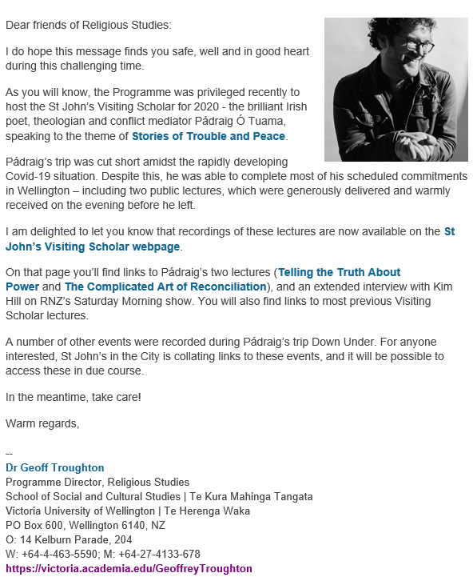
MISSION STATEMENT OF ST ANDREW'S ON THE TERRACE

To create a lively, open Christian faith community,
to act for a just and peaceful world, and to be catalysts for discovery,
compassion and celebration in the capital.

MINISTRY AT ST ANDREW’S – THE TEAM
Interim Moderator | Catriona Cairns
Parish Council Convenor | Lynne Dovey
Stated Supply Minister | Niki Francis
Treasurer | Paul Barber
Facilities Management Group | Sandra Kirby
Pastoral Care Team | Linda Wilkins, Maxine Cunningham, Brian Burrell, Pat Booth and Katrina Harper
Pastoral Convenors | Linda Wilkins, Maxine Cunningham, Brian Burrell and Pat Booth
Church Music Coordinator | Mark Stamper
Theologian in Residence | Lloyd Geering
Presbytery Representative | Lois Robertson
Concert Coordinator | Marjan van Waardenberg
Faith in Action Co-ordinator | Margaret Rushbrook
Rainbow Room Coordinator | Jules Collinson
Centre Manager | Laetitia Brunell
Office Administrator | Jillene Everett
Facilities Assistants | Claudia Monkhouse and Kate Crichton
Roster Coordinator | Rosemary Lawrence

St Andrew’s on The Terrace
www.standrews.org.nz
30 The Terrace – P O Box 5203, Wellington 6145


Office Hours: 9 am – 5 pm Monday to Friday
Phone (04) 472-9211
office@standrews.org.nz

Interim Moderator – Rev. Catriona Cairns
catrionajcairns@gmail.com, Cell: 0273059129







