**Sermon Wisdom and Climate change** March 2020

John Howell

Proverbs 8: 10-21

Mt 5:1-12

## Proverbs 8:10-21

10Take my instruction instead of silver,  
and knowledge rather than choice gold;  
11for wisdom is better than jewels,  
and all that you may desire cannot compare with her.  
12I, wisdom, live with prudence,  
and I attain knowledge and discretion.  
13The fear of the Lord is hatred of evil.  
Pride and arrogance and the way of evil  
and perverted speech I hate.  
14I have good advice and sound wisdom;  
I have insight, I have strength.  
15By me kings reign,  
and rulers decree what is just;  
16by me rulers rule,  
and nobles, all who govern rightly.  
17I love those who love me,  
and those who seek me diligently find me.  
18Riches and honor are with me,  
enduring wealth and prosperity.  
19My fruit is better than gold, even fine gold,  
and my yield than choice silver.  
20I walk in the way of righteousness,  
along the paths of justice,  
21endowing with wealth those who love me,  
and filling their treasuries.

## Mt 5:1-12

5When Jesus saw the crowds, he went up the mountain; and after he sat down, his disciples came to him. 2Then he began to speak, and taught them, saying:

3“Blessed are the poor in spirit, for theirs is the kingdom of heaven. 4“Blessed are those who mourn, for they will be comforted. 5“Blessed are the meek, for they will inherit the earth. 6“Blessed are those who hunger and thirst for righteousness, for they will be filled. 7“Blessed are the merciful, for they will receive mercy. 8“Blessed are the pure in heart, for they will see God. 9“Blessed are the peacemakers, for they will be called children of God. 10“Blessed are those who are persecuted for righteousness’ sake, for theirs is the kingdom of heaven. 11“Blessed are you when people revile you and persecute you and utter all kinds of evil against you falsely on my account. 12Rejoice and be glad, for your reward is great in heaven, for in the same way they persecuted the prophets who were before you.

While Proverbs 8 begins with the saying “wisdom is better than jewels” verses 21-2

says:

20I walk in the way of righteousness,  
along the paths of justice,  
21endowing with wealth those who love me,  
and filling their treasuries.

It is hard to date the book of Proverbs with accuracy, but we can locate it about the later period of the monarchy of the first temple, perhaps as early as the David/Solomon era. (Perdue p 38.) Generally it was a time of affluence, international trading and consolidation of the temple and its culture. The sages valued wealth for its many benefits and regarded it as a divine gift for following the wisdom tradition. (Perdue p61). Following verse 18:

18Riches and honor are with me, enduring wealth and prosperity.

- this idea has been latched onto by particularly American evangelists and we refer to it as the “prosperity gospel”.

The context for the Beautitudes, found in Mt 5 is quite different. The Christian community as refered to in Mt 5 was persecuted and reviled – very much an oppressed minority. The beautitude sayings are not unlike wisdom sayings, but the theme that is extolled is to be blessed.

* The Greek word translated "blessed" in the Sermon on the Mount is *makarios*, and it's meaning is a little more nuanced than what we get from happy. The idea behind makarios is that something is made "large" or "lengthy." When God "blesses" us, He "extends" His benefits to us.
* Of course, the person to whom God's benevolence is extended is the happier for it, which is why the word *makarios* is sometimes translated "happy" or "fortunate" or "enviable."

There is another word “eudemonia” (Greek: εὐδαιμονία ), translated as happiness or well-being.

* Eudaimonia is commonly translated as happiness or welfare;

however, "human flourishing or prosperity" and "blessedness" have been proposed as more accurate translations. (Wikipedia)

* Collins dictionary defines well-being this way: It is a person's state of excellence characterized by objective flourishing across a lifetime, and brought about through the exercise of moral virtue, practical wisdom, and rationality.

So I am suggesting that to seek to be blessed, can also be understood as happiness or well being, flourishing or prosperity. However what is absent in the Beautitudes is the connection that this will lead to wealth. Material prosperity is absent, instead the treasure is found in our character, in the spirit of a person.

To seek well being, to be happy, to be blessed, to flourish, requires a holistic approach, not just having some wealth, or health, or intelligence, or insight but all of those in a connected inter-relationship. I need to care for myself, my neighbour and community, and the earth my home. We can say: “If we get the balance right we are wise, we are well.”

The Maori perspective of “Hauora” encapsulates it. Hauora is presented as a house, a whare with strong sides. All are needed to create shelter and well-being.

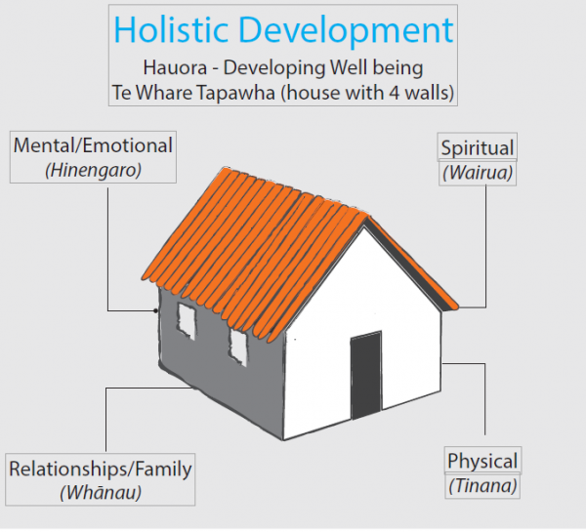

So let me compare Proverbs 8 with Matthew 5:-

**Prosperity** *compared with* **Blessedness**

context of: affluence oppressed minority

empire building counter-culture

wealth is a divine gift seeks the “Kingdom of God”

wealth does not feature

The main point I wish to make here is ***context*** is crucial in the application of what it is to be wise. Prosperity is appropriate in an affluent society, but when our society is depleted or impoverished, then our energy is spent on surviving not thriving. In a depression or a war, we seek to survive, and hopefully survive with a set of values worthy of a civilised society.

Now wellbeing economics is a current theme in our budget setting and economic framework. To discuss this I will use the approach by Paul Dalziel and Caroline and Joe Saunders. (see photo of book)

Their title outlines their argument: “Wellbeing economics – The capabilities approach to Prosperity.”

Well-being here is tied to prosperity, and if you like, it is a secular form of a prosperity gospel.

They develop 24 propositions. Let me draw to your attention proposition 9



Proposition 9 *Present and future wellbeing can be enhanced if children grow up in households that are able to access adequate economic resources.*

I will come back to this proposition, but first make a point about context.

You may recall my main point: context is crucial in what it is to be wise and blessed.

What is changing in our planet is the climate. We have local examples of extreme floods, and more intense droughts. Let’s look at a graph from the webpage of NASA.

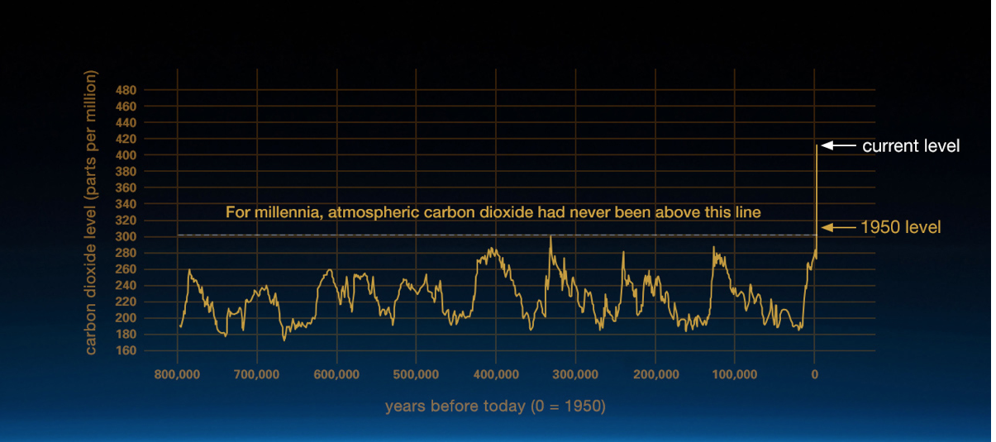

This graph demonstrates with great clarity that the context for our civilisation has changed, and we are in new territory, a new era. Some might define it as the Anthropocene.

The superfires that have just plagued Australia were descibed by a fire chief as “this is not normal” Just after the superfire there was a short period of rain. I heard a south Australian farmer rejoicing at the rain and he said he was looking forward to more rain to break the drought. He did not say this, but he implied, “and get us back to normal”.

Since then heavy and flooding rain has hit parts of Australia as a reverse extreme event.

Well this graph shows we are in a different normal now. And the path our world is on is not doing a sudden U turn. The scenario of what lies ahead is a depleted planet, with extreme weather events, rising sea levels, and scarcity of resources, such as water. I am not predicting the end of the world. My observation is that our context is changing, and we are in a new normal, and unknown parameters.

David Attenborough in a recent interview was asked whether there is hope that things can get better for our planet. He replied that we can only slow down the rate at which things get worse.

So let’s look at proposition 9 again.

Proposition 9 *Present and future wellbeing can be enhanced if children grow up in households that are able to access adequate economic resources*.

That proposition is based on the assumption of a future prosperity, that we are in an affluent society. It is the word “adequate” that is difficult here. Adequate suggests enough, but the unknown we are heading into is of scarce resources, and that includes that we may not have enough.

I suggest it needs revision to include an economy where resources area scarce and at time inadequate:

*To have present and future wellbeing for our children, we need to learn to live within the economic resources available, especially renewable and non-polluting resources.*

Proposition 1 for Dalziel et al is:

The primary purpose of economics is to contribute to enhanced wellbeing of persons.

Perhaps it is time to use an older definition of economics as the management of scarce resources.

So to return to my main point: context is crucial in the application of what it is to be wise. I advance the following proverb:

* The wise person seeks a state of blessedness,
* the foolish person seeks a prosperity gospel.

I attended a lecture at Victoria University of Wellington in 2014, by a Taiwanese professor of science. Professor Yuan T Lee, President of the International Council for Science, believes a deep transformation to global sustainability is needed, beginning immediately with dramatic reductions in human footprint, population growth and consumption. His simple formula was “Shrink + Share”.

Shrink: our world is changing in ways different from the natural parameters of the last 800,000 years. Our world is failing to adequately address this human induced change. It may be imposed on us.

Share: That is a moral issue, and a religious issue. We need to find new ways in which we can be blessed.

If we seek the path to blessedness, then we will find the virtues of wise action.

* Enrich our grace with knowledge of all kinds.
* Seek wisdom in the wisdom literature - the proverbs, the psalms, the parables, the sayings, the stories, the life of Christ, the witness of the disciples and the apostles of what it is to be (w)holy. and blessed.
* Sometimes we need to be “saved”, but saved from foolishness. It is through wisdom we find the good life and the common good.
* The model we can follow is in Christ, who shifts from the stories of law to the stories of grace.
* This experience of grace lived in wisdom is the religious contribution to the challenges of our time.

**Sources:**

David Attenborough: http://theconversation.com/climate-change-how-do-i-cope-with-our-planets-inevitable-decline-128593

Dalziel, Paul; Saunders, Caroline and Saunders, Joe; Wellbeing economics, Palgrave, 2018 (free and open access at: <https://www.palgrave.com/gp/book/9783319931937> )

Hauora: <https://www.slideshare.net/selbie/hauora-wellbeing>

Mulgan, Tim; Ethics for a broken world, McGill-Queens’s University Press, 2011

NASA, <https://climate.nasa.gov/evidence/>

Perdue, Leo G; Wisdom Literature, John Knox Press, 2007

**Story: Koala and the rain** March 2020

Koala was very glad to see the rain. After the superfires, rain was needed. It was not much rain to start with, yet after three years of drought, any rain was welcome.

The early rain did not put all the fires out. Many fires kept burning. Later, heavy rains and floods came and extinguished virtually all the fires, which was good, even if the floods were damaging.

During this time, Koala wondered if he should pray for rain.

He asked Roo this when he saw him next. Roo had bandages on his feet.

Roo’s reply was thoughtful. “The long term answer”, he said, “is to stop burning coal. Yes, of course need rain, and there is no harm in hoping for rain, as long as we confess we pollute the air when we burn coal and oil, and seek in our prayer for the will to do something about it.”

“I heard” said Koala, “that there were naughty children lighting these fires.”

“Yes”, responded Roo, “I heard that on Dingo News. Dingo News only gives half the story. But yes, there were naughty people lighting fires.”

Snake popped his head up out of the ground. “Everything will return to normal. After this rain, things will settle down.”

Koala was suspicious of snake. Snake had a way of wriggling in and out of things.

Roo thought snake spoke with a forked tongue.

Koala was not so sure that everything would return to normal. These fires were superfires. They had burned a lot of his gum trees and many thousands of his cousins. A lot more than normal. He will find a new home, but was it only a matter of time before it too will catch fire?

Roo was about to hop off in his new Nike supershoes. They had carbon fibre in them and Roo thought this is a good use of carbon. “And we are going to need all the new technology we can”, he thought.

He turned to Koala and said: “You don’t play with fire. Perhaps that is what we should be praying about.”

**©** John Howell