

Hato Anaru o Te Parehua
Founded 1840
Order of Service

19 April 2019

Good Friday

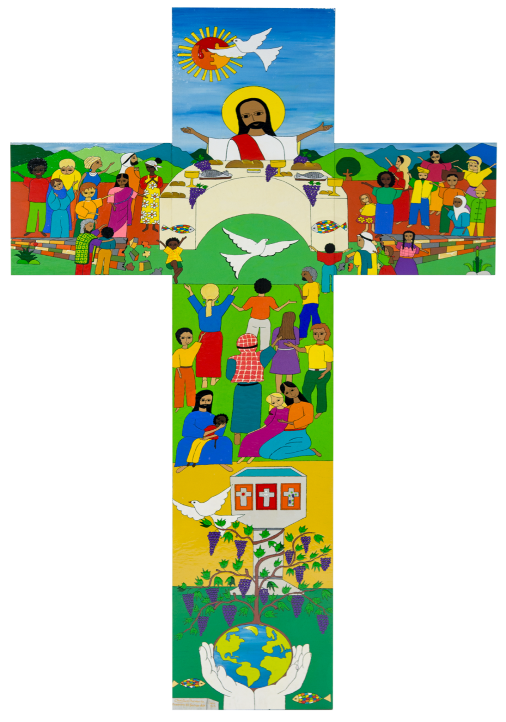

El Salvador cross: Joint Catholic-Lutheran Commemoration of the Reformation

Welcome to St Andrew’s on The TerracE
Wherever you are on your faith's journey,
wherever you have come from and wherever you are going to,
whatever you believe, whatever you do not believe, you are welcome here.
Please join in the congregational responses printed in bold italics.
Please stand if you are able, for the hymns and the offering prayer.
We will sing the hymns without announcement.
To use the loop system in the church, turn your hearing aids on to the appropriate setting.
Please note your nearest fire exit.
The church and hall have been earthquake strengthened. In an earthquake: drop, cover and hold.

GREETING by Dorothy McRae-McMahon

We gather again on this Good Friday
at the foot of the cross
which calls us on,
not in shame,
not in fear,
but more deeply into the costly journey
towards life.

There is wounding,
there is weeping.
In Jesus Christ,
God is not separated from that.

CALL TO WORSHIP by Dorothy McRae-McMahon

In the shadow of our suffering
Is the suffering of Jesus.

In the shadow of our weakness
Is the vulnerability of the Christ.

In the shadow of our pain
Is the God who cried out.

We are never rejected
We are never left alone.
PROCESSIONAL HYMN We walk in silence
Words: Bronwyn Angela White. Tune: Winchester WOV 264
We walk in silence while the earth
Quivers and cracks beneath our feet
Swallows our dreams and shatters worth
Solemn, we trudge to hearts’ dull beat.

We walk while singing, motley choir of
traitors, lovers, meek and proud
Small sparks of apostolic fire
light up the path, lighten the shroud.

We walk in solidarity and
sing of hope that never dies
We march to end disparity
graves open as our spirits rise.

We walk the way that has no end
Free to evolve, transform our creed
Hearts, torn like curtains, start to mend
Love rising now in word, in deed.

WELCOME AND INTRODUCTION

Chant “Whichever way you turn”
Words: The Quran- The Cow 2:115” /JP Newell Music: Linda Larkin
Peter, Jules, Jess, Katrina and Dick.

“Whichever way you turn, there is the face of God”

Would any who would like to walk round the stations please gather at the front right hand side of the church at the end of the chant.

FIRST STATION - Jesus is condemned to death Mark 15: 1-5, 11-15
Lynne Dovey
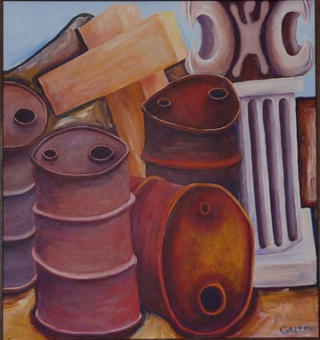
Meditation: We contemplate the role of the chief judge in the modern world. S/he is required to weigh carefully all of the evidence and circumstances of an alleged crime. This requires a deep understanding of the human condition, of the gravity of the situation. A judge needs the ability to switch between condemnation and compassion. “Judgement… requires…the balancing of competing interests and principles” (Waleed Aly, Australian journalist). S/he must be certain that the punishment corresponds to the crime but also understand what the punishment means for an individual who is found guilty. Failure to understand these things can lead to a failure of justice.
Prayer: Looking back, we ask, did Pilate try to understand Jesus, who challenged the old
beliefs and ways? Did he understand that the chief priests were threatened when
this young man came preaching justice, peace and love? Did Pilate deliberate
carefully? And what of the crowd? Would we have been in that crowd?
Wise God, may we understand that to be just is to be deeply human and that to
be deeply human is also to know God.

Compassionate God, may we and all the world know your presence.

Sung Response AA50 ‘God of freedom, God of justice’
Words: Shirley Murray vs 1&2
Tune: Picardy, French Traditional carol melody 17th – 18th C
God of freedom, God of justice,
you whose love is strong as death,
you who saw the dark of prison,
you who knew the price of faith,
touch our world of sad oppression,
with your Spirit’s healing breath.

SECOND STATION – Jesus takes up his cross Mark 15: 16-20
Sue McRae

Meditation: First they tried to shame and humiliate you,
they taunted you for the threat you posed to authority,
subjecting you to mental and physical abuse out of fear
that your popularity might lead to their downfall –
and that was just the start of a painful journey to death.
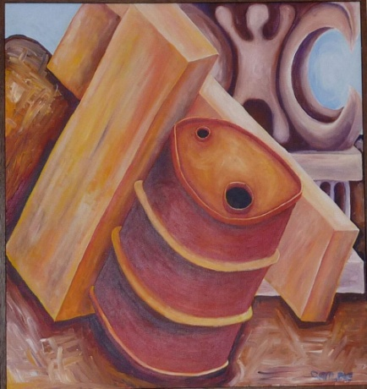
Prayer: We pray for everyone mocked and derided
for their beliefs and principles and also for those
driven by their own insecurities to hurt others.
Why can’t we all just live and let live?
We pray for healing and hope.

Compassionate God, may we and all the world know your presence.

Sung Response
Rid the earth of torture’s terror,
you whose hands were nailed to wood;
hear the cries of pain and protest,
you who shed the tears and blood;
move in us the power of pity
Restless for the common good.

THIRD STATION – Jesus falls for the first time Isaiah 53: 2
Wendy Matthews
Meditation: Jesus, the man for all seasons, who on Palm Sunday was given a rousing welcome into Jerusalem, is now condemned to death by the religious leaders fomenting the fickle crowd. Jesus falls under the weight of the heavy, rough-hewn cross - feeling his own mortality and struggling with despair.
When our son, Alastair fell for the first time last September, we had to accept that his body was shutting down. He had fought so bravely for two and a half years to beat the cancer. Now he and we had to face his imminent death.
As Jesus falls we get a small glimpse of the mental and physical agony he must be suffering.
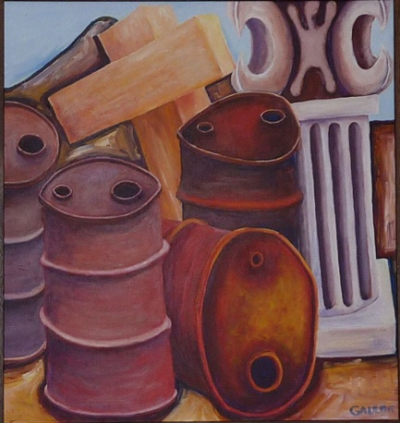
Prayer: We pray for those who are suffering physically and for those who are imprisoned and tortured for their beliefs and actions to help others.

Compassionate God, may we and all the world know your presence.

Sung Response Words: Fiona McDougal
When in deep despair we have fallen,
you who walked the stony road,
strengthen us to walk one step further,
you who bore a heavy load,
friends and whanau can sustain us,
though for now our head is bowed.

FOURTH STATION – Jesus meets his mother Luke 2: 22, 34, 35
Gillian Feist
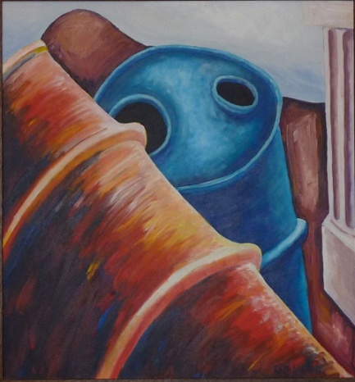
Meditation:
OH MY SON -MY BELOVED SON -
My heart is splitting in two as I watch you trudge painfully uphill to the place of crucifixion –
Crucifixion – such a painful form of death reserved by the Romans for runaway slaves and those seen as a threat to society – insurgents who subvert Roman law & order & are seen to disturb Pax Romana - and YOU, of all people are seen as a threat!
Oh, Jesus, WHY, Oh Why -
Couldn’t you just stay at HOME WITH YOUR FAMILY instead of GOING OFF WITH YOUR FRIENDS filled with VISIONS OF ANOTHER WAY OF LIFE –
You challenged the scribes and Pharisees, our religious leaders, with your way of life and teaching, crossing barriers of race, class and gender - eating with those considered unclean -fishermen, tax collectors, gentiles, and women – those on the edges of society.
Yours was a prophetic voice against imperial violence and injustice. – And look where that has got you – a broken hearted Mother and frightened scared followers who have deserted you in your hour of need. ------

Prayer Oh, Lord, on this day of all days we think of those Mothers throughout history who have wept tears of anguish and stood with broken hearts as they’ve seen their sons and daughters killed, shot, bombed as they’ve fought and stood for justice, equal rights, dignity and against war - and for those killed even as they prayed in a Mosque in Christchurch.

Compassionate God, may we and all the world know your presence.

Sung Response Words: Fiona McDougal vs 1&2
Tune: Affliction, Jillian Bray
With mother-love a heart will break
in helplessness and grief
to watch a child who’s suffering
unable to relieve.

FIFTH STATION – Simon helps Jesus to carry his cross Mark 15:21
Graham Howell
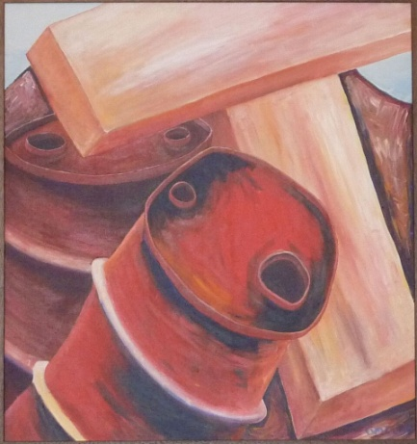
Meditation:
I was yelled at by a Roman soldier' "You, carry this cross". I stopped, worried. Very worried. What had I done? Is it for me! I am a simple farmer, rarely in the city. The soldier saw the alarm on my face and said. "Not for you, it's for the King of the Jews" and he laughed. I was relieved.

Then I saw this man. I had heard of him, and he smiled at me. It was radiant smile. It was hard to know why. I was and am still bewildered. Why kill such a man? Why is he smiling simply because I am carrying his Cross? Does he not understand? But days later I realised it was I who did not understand.

Prayer: We pray for all those who have walked the same road Jesus took to Calvary. Thousands have undertaken this journey, from pre-Roman days to, in some countries, even today. In the eyes of the state and religious authorities the executions were and are justified. Whatever the method, be it crucifixion, hanging or gas chamber;
Whether Mt Eden Gaol, a State, in the USA, in the Middle East or where ever, we pray for compassion in how our government bodies treat its wrong-doers.

Compassionate God, may we and all the world know your presence.

Sung Response
Confronted with another’s need
their burden we can share
stand with them in their suffering
by being present there.

SIXTH STATION – Veronica wipes the face of Jesus Matthew 25: 35-36, 40
Laura Galland

Meditation: In the long and arduous journey leading to Golgotha in which every step was an endlessly heavy burden, the procession approached the house of the woman called Veronica. There she had often served Christ, his disciples and friends, and offered them accommodation for the night. Like the other women close to the Redeemer she wanted to do whatever she could to help make His sufferings more bearable and also to show her deep reverence. When the procession came to a halt, courageously Veronica rushed out of the house and without hesitating pushed her way through the crowd and the soldiers, offered the most precious material that she owned to the Redeemer, and at the same time she bent her knee in devotion.
Compassionately she wiped the blood and sweat from His face. Through that gesture she kept alight the lamp of humanity and kept alive our faith.
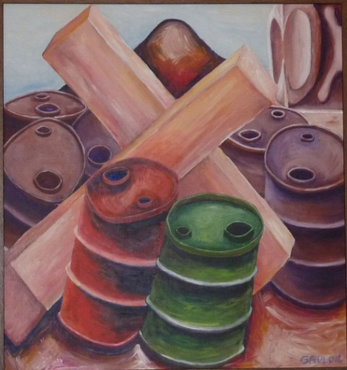
Prayer: We pray for those who have the courage to be a bridge for those who suffer from depression and a feeling of hopelessness;
for those who persist in resilience and patience to endure a life of challenges – that they may also see those challenges as blessings;
and for those who suffer from exile, poverty and exclusion;
that they may all perceive that Veronica’s gesture is a challenge to look at the world today in faith and hope.

Compassionate God, may we and all the world know your presence.

Sung Response HIOS 106 ‘O God I cry to you in pain’ vs 2 & 4
Words: Shirley Murray
Give me the strength to face my ill
to trust in skill and care
to bless the hands that help me heal
and find your Spirit there.

Within the comfort and the love
that human touch can give,
restore in me a larger sense
of what it is to live.

SEVENTH STATION – Jesus falls the second time Isaiah 53:7
Lynne O’Brien
Meditation: It is in our worst moments of desperation and despair that we find ourselves, brought to our knees, in full submission, yielding our own cross that has become too much to bear. Ready, silent and without complaint, we hand our suffering over to God, unaware of the new direction God may lead us in but open, nonetheless to God's direction. Our fight is gone, the challenge overwhelming. We are beyond search for answers; for a way out. We have handed over the reins of our life’s journey. In our despair, like Jesus before the cross, we wait.
Yet, in the midst of our sorrow and all-consuming exhaustion, there emerges a quiet strength; the beginning of a new understanding and perspective such that we have not known before, and a compassion and well-spring for love that we did not think were possible. Not from so much brokenness.
Like a lamb to the slaughter, Jesus was brought; broken and beaten before his accusers. Without complaint, He committed His fate to God – and to the cross - because He loved God and trusted God's will. So too, in our trials do we submit ourselves to God for our own unknown death, resurrection and rebirth.

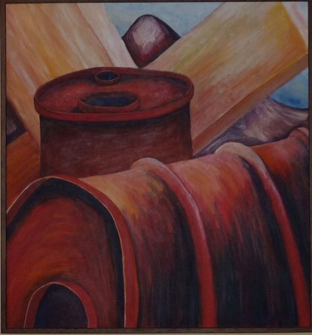
Prayer:
Lord, in our worst moments of rejection, humiliation, isolation, disparity and suffering, may we find the strength of humility and the wisdom of your love to be silent and listen;
so we might better understand you will, and in those moments… find resurrection, renewal…and grace.

Compassionate God, may we and all the world know your presence.

Sung Response HIOS 52 ‘God who weeps’ vs 1&2
Words – Marnie Barrell. Tune: Barry Brinson, Lacrimosa
God who weeps when we are weeping
maker, lover, friend of all,
we commit into your keeping
those who suffer, struggle, fall.
Plant the seeds of peace inside us
in these days of fateful choice;
let your word and wisdom guide us
as we listen for your voice.

EIGHTH STATION – Jesus meets the women of Jerusalem Luke 23: 27-28
Margaret Harper

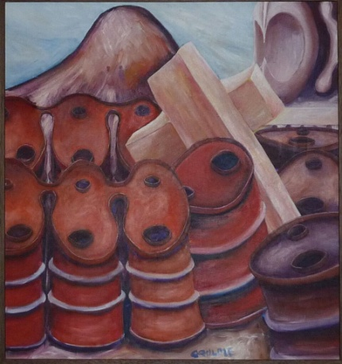
Meditation: This station is based on Luke 23 verse 27 in which Jesus says “Daughters of Jerusalem do not weep for me, weep for yourselves and your children.” He then goes on to quote Hosea’s prophecy of future destruction. The artist depicts the women as a tightly linked group. Is he seeing them as the quasi-religious group of lamenters of one commentator? They may just have been a group who followed to see what was happening. Jesus is able to think of them rather than himself; but is he really showing compassion or telling women to repent as in some traditions? I think he is warning them of the growing annoyance and power of the Romans and their collaborators.

Prayer: God help us all work together to avoid undue climate change, which would be as devastating for the world as the sacking of Jerusalem in 70 CE was for its inhabitants.

Be compassionate God, may we and all the world know your presence.

Sung Response
Christ, enduring hate and violence,
hounded to a martyr’s death
calmly meeting taunts with silence,
speaking peace with your last breath;
peace, courageous and demanding,
binds us as we walk your way.
May our wills, at your commanding
turn to acts of peace today.

NINTH STATION – Jesus falls for the third time Isaiah 53: 7
Paul Franken

Meditation: By falling and being knocked about like an old drum, YOU showed us it is all right to slip up and fall down.
When I fall, again and again it is inescapable that I want to give in, give up.
Surely a peaceful release of suffering at this stage is allowed; Suicide as an alternative solution looks like a blessing, an outcome, an end to my trouble; You did not accept this opportunity. You can and will give me strength whether and when I face Euthanasia or suicide. ‘Get up and carry on’- Somebody will be there to help me---
Would I have helped or assisted you, had I seen your body crumple for the third time? Will you allow me to get up again and again? Please? Help me even if I stood by when you fell.
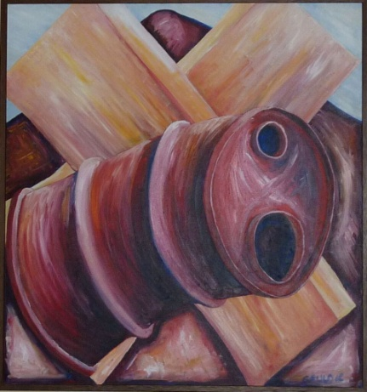
Prayer: Jesus, thanks for allowing us to walk beside you, for allowing us to slip- as we do many times- Give us the courage to get up again and again.

Compassionate God, may we and all the world know your presence.

Sung Response: ‘Give Thanks for Life’ vs 2 AA45
Words: Shirley Murray. Tune: Sine Nomine. WOV384

Give thanks for those
who made their life a light
caught from the Christ-flame,
bursting through the night,
who touched the truth, who
burned for what is right,
Alleluia!

TENTH STATION – Jesus is stripped of his clothes Mark 15: 22-24
Trish McBride
Meditation: Jesus was stripped of his clothes twice, once to be flogged, and this time to be crucified naked. In the meantime, his blood would have congealed and adhered to his tunic, so the second stripping would have been far more painful than the first. All we other humans also endure painful strippings – of dignity, freedom, safety, health, family, friends, and eventually of life itself. For some these are more deeply wounding than for others.
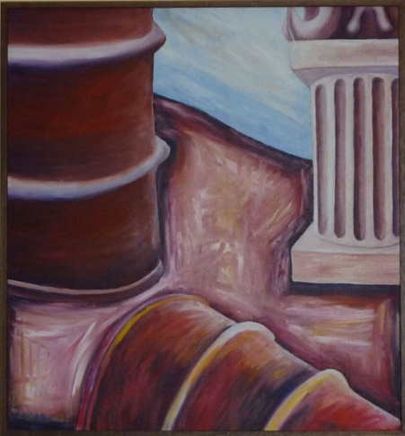
Prayer: Loving God, we hurt for so many here and world-wide who are stripped of their basic rights and needs. May we be willing to do some stripping in our own lives to help with this. And when we are unwillingly stripped of what matters to us, may we find, even in the pain, patience and courage to believe in some future resurrection.

Compassionate God, may we and all the world know your presence.

Sung Response COC 4 ‘All who would see God’s Greatness’ vs 1 & 2
Words: Marnie Barrell. Tune: Obeisance, Ian Render
If you would share God’s riches
Draw near, reach out and touch;
God had only love to offer,
Enough for us, and too much.
See now God’s treasure, made so poor,
Naked the God that we adore.

ELEVENTH STATION – Jesus is nailed to the cross Luke 23: 35-38
Molly Seah

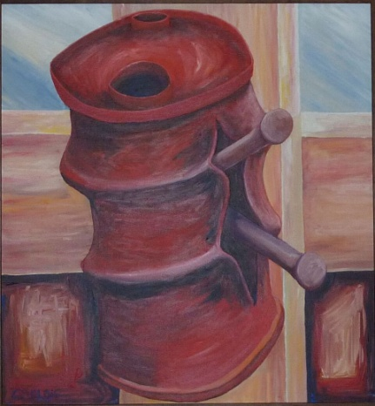
Meditation: Witnessing Jesus’ agony as the nails impale him to the cross and hearing the voices mocking
him, I stand afar, numb with fear and desperation.
If the rocks and stones in this heart shattering place of despair could speak of what they
witness, they would with one voice along with mine cry out to God for mercy and consolation.

Prayer: Jesus, as we see your suffering, we think of the people who face oppression, persecution, torture and violence in so many parts of the world. We pray for courage and determination to advocate for justice and freedom to be restored wherever deep change is needed to transform society.

Compassionate God, may we and all the world know your presence.

Sung Response
Stand in the holy silence,
while earth with heaven sings
that here now for our beholding
is love that upholds all things.
Strange is this love that draws us near;
glory of God among us here.

TWELFTH STATION – Jesus dies on the cross Luke 23: 44-46
Frances Porter
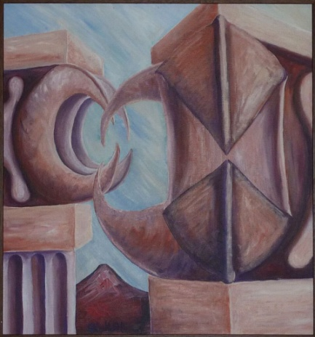
Meditation: Jesus was brought to the 'Place of a Skull' outside Jerusalem and crucified along with two thieves with the charge of claiming to be 'King of the Jews'. According to Mark's gospel he died some six hours later.

It is all over. Too much has been happening. Too much we do not understand. Our entry into Jerusalem had been triumphant. The crowd had shouted 'Hosannah in the Highest', the Messianic title for the hoped-for King of Israel. Strangely Jesus did not seem to be excited by this popularity. In what turned out to be our last supper with him he talked about his coming death and of about how he would be betrayed by one of US.
And a little while later a similar Jerusalem crowd called for his death, persuading even a sceptical Pontius Pilate to have Jesus crucified as a criminal . It had also been one of us, Judas Iscariat who, with a kiss, identified Jesus to the Roman soldiers and even more upsetting, it was Peter, our leader, the one to whom Jesus had said,' On this rock I will build my church', Peter, who after Jesus had been arrested had vehemently denied ever knowing him.
And looking back to that last supper the strangest things were said and done by Jesus himself.
And now it is all over. Just all over. Some of us had hoped that the Roman yoke would be lifted and that Jesus himself might become 'King of the Jews'. But that hope came to nothing. He was crucified between two other 'criminals'.
And now Jesus is dead. We had hoped for so much and now, along with Jesus , those hopes have gone. It is just all over.

Prayer: We remember those whose hopes have been destroyed and are exhausted by the struggle to reach a dream of a better way.

Compassionate God, may we and all the world know your presence.

SMALL GROUP OF WOMEN APATT 25 ‘Lord Jesus Christ the light you brought us’
Words: Shirley Murray (altered with permission of author) Music: Jillian Bray

Lord Jesus Christ,
the light you brought us
fades in the dark,
with all that you have taught us,
shadows beset
the hope that caught us,
fearful your people now.

Lord Jesus Christ,
our lives reveal us
faithless, afraid
without your strength to steel us,
losing the words
that hold and heal us,
stumbling your people now.

Lord Jesus Christ,
your friends will fail you,
love that betrays
with kiss and sword assail you,
here on a cross
the powers have nailed you,
silent your people now.

Silence

Sung response AA 31 ‘ E te Atua’
Tune Kum Ba Ya arr. Nicola Jansen and Guy Jansen

E te Atua awhina mai, ( trans - O God help us…… forever and ever)
E te Atua awhina mai,
E te Atua awhina mai,
ake, ake tonu e,
ake, ake tonu e.

E te Atua aroha mai……….. (trans - O God love us…. )

THIRTEENTH STATION – Jesus is taken down from the cross Mark 15: 4
Anna Smith

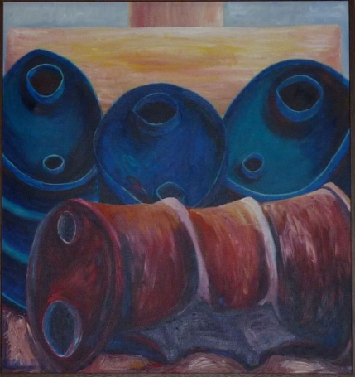
Meditation: And now, at the end of his suffering, it is clear that, for all the dismay which filled his followers’ hearts, for all the power of hatred and cowardice, he was never alone. Under the cross we see the three Marys – the faithful ones who remained with him; who, we imagine, like women in so many cultures and faiths, lovingly tended to his body, before it was laid in the tomb.

Prayer: May we remain with those who are suffering in Christchurch, in the wider Muslim community and in other marginalised groups. May we not desert them when the public’s attention moves on from the mosque attacks to other things. We pray that we will continue to stand with the vulnerable, building bridges in our own communities and working more widely for greater understanding and tolerance.

Compassionate God, may we and all the world know your presence.

Sung Response AA151 ‘When human voices cannot sing’ vs 1
Words: Shirley Murray. Tune: St Columba, Irish traditional

When human voices cannot sing,
and human hearts are breaking,
we bring our grief to you, O God,
who knows our inner aching.

FOURTEENTH STATION – Jesus is laid in the tomb Mark 15;46b-47
Jenny Simpson

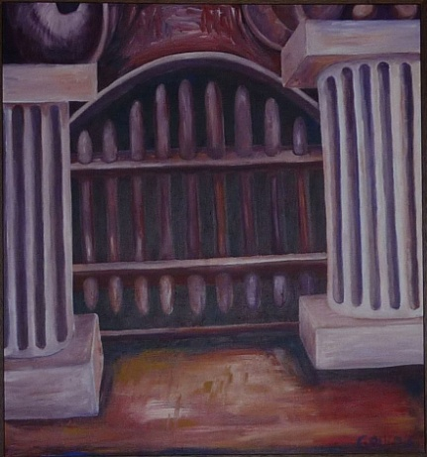
Meditation: Jesus, they laid you dead in the tomb, and sealed it with a large stone. All that remained, your spirit gone. And it was so you were sealed up, to be just historical , eventually crumbling, turning to dust.
And we do that still.
We do it when we argue about bits of faith, biblical language rather than meaning, when we read about you in theological books rather than turn inwards and find you waiting , when we try to hear about you from learned people rather than those wounded, peripheral , knowing people.
We do it when we are scared to admit you are everything to us.
When it is your face we see scarred in our world.
When it is you who heals our sore heart.
But the women were there, two of the most wilfully misunderstood in all the world, hearts shattered, and yet they stayed. Those wonderful women.

Prayer: We pray for people who stay, who hold on, when all hope has gone, when all others have left, who stay.

Compassionate God, may we and all the world know your presence.

Sung Response

Make real for us your holding love,
the love which is your meaning,
the power to move the stone of death,
the hope of Easter morning.

JESUS' PRAYER
Eternal Spirit, Life-giver
Pain-bearer, Love-maker
source of all that is and that shall be,
Father and Mother of us all,
loving God, in whom is heaven:
The hallowing of your name echo
through the universe!
The way of your justice be followed
by all created beings!
Your commonwealth of peace
and freedom come on earth!
With the bread we need for today, feed us.
In the hurts we absorb from one another, forgive us.
In times of temptation and test, strengthen us.
From trials to great to endure, spare us.
From the grip of all that is evil, free us.
For you reign in the glory of the power that is love,
Now and forever. Amen.

Please stand

SENDING OUT
We go on our way
and Jesus goes ahead of us
We do not need to be afraid.
God is love
and love is more powerful
than fear or death or evil,
and we are greatly loved.
We go out into the world
in the power of the spirit of Christ
to walk through darkness and uncertainty
towards the joy of Easter Day.
We go in peace.

AROHANUI BLESSING AA 95 ‘May the mystery of God enfold us’
Words: Joy Cowley. Tune: Marlborough Sounds, Ian Render

May the mystery of God enfold us,
May the wisdom of God uphold us,
May the fragrance of God be around us,
May the brightness of God surround us.

May the wonder of God renew us,
May the loving of God flow through us,
May the peace of God deeply move us,
May the moving of God bring us peace.

RECESSIONAL SOLO Jane Keller HIOS 123 (i)‘Something’s dead inside me.’
Words: Joy Cowley. Tune: Rain Dance, Colin Gibson.

Something’s dead inside me,
Some yesterday is slain,
My heart is hung upon a cross,
My thoughts are filled with pain
And yet there is within me
A hope I can’t explain
For in the darkness I can see
God dancing in the rain,
God dancing in the rain.

I surrender to the mystery
Of loss that turns to gain,
The little seed of wheat must die
To become a field of grain,
And I know it’s in this time of grief
That Christ is risen again
For in the darkness I can see
God dancing in the rain,
God dancing in the rain,
God dancing in the rain.

Thank you to everyone who participated in the creation of this service; to all who contributed music, meditations and prayers and technical expertise.

INFORMATION ABOUT ROBERT GAULDIE AND THE PAINTINGS

“Bob Gauldie was an accomplished researcher and academic who built a reputation for pushing boundaries during a career which included more than 150 scientific publications. He was also not afraid of pushing boundaries in his other great love, painting, with one work irking religious traditionalists and coming close to landing him in trouble with the law.

Following an exhibition of his paintings in 1985, Professor Gauldie was asked to paint the Stations of the cross for Wellington Presbyterian Church St Andrew’s on The Terrace. The 14 stations tell the story of Jesus from his death sentence to his entombment, but those painted by Prof Gauldie and first shown at Easter 1987 caused a stir by depicting Christ as a 44-gallon oil drum. The Evening Post newspaper received several letters attacking the work as “blasphemy” and Prof Gauldie recalled how a senior Wellington police officer warned he could be charged with criminal blasphemy, though in the end no action was taken.

Prof Gauldie said using a 44- gallon drum to symbolise Jesus depicted the stations in a way that was “realistic in the religious sense”. “As a symbol they are ubiquitous, loud and associated with trash. They were ideal for my purpose to portray the Stations of the Cross as the brutal murder, the clangorous, violent trashing of Jesus, the reduction of all his teachings to a worthless and brutalised body that was empty of life”.

Robert Gauldie’s obituary in The Dominion Post 18th June 2011.
Available at http://robertgauldie.files.wordpress.com/2011/07/bob_gauldie_obit.pdf

EASTER AT ST ANDREW’S ON THE TERRACE, 2019

Saturday 20 April, 10am for 10.30am
Holy Saturday
Quiet hour beginning 10.30am


Sunday 21 April 10am
Gathering for Easter Day with Communion

Further Information www.standrews.org.nz;
email minister@standrews.org.nz or reservations@standrews.org.nz
Phone 04 472 9211

PERMISSIONS:

Words reprinted by permission of CCLI Licence 341550 unless otherwise stated.

‘We walk in silence’. Words © Bronwyn Angela White. Tune: Winchester (Public Domain). Used by permission of the author.
‘Whichever way you turn.’ Words: The Quran-Book 2/J.P. Newell. Tune by Linda Larkin © 2010 Linda Larkin. Used by permission of the composer.
‘God of freedom, God of justice’. Words © 1992 Shirley Erena Murray. Tune: Picardy (Public Domain)
‘When in deep despair we have fallen’. Words © Fiona McDougal. Words used by permission of the author.
‘With mother-love a heart will break’. Words © Fiona McDougal. Tune: Affliction © 2008 Jillian Bray (admin. by Sylvia Fountain). Words used by permission of the author.
‘O God I cry to you in pain’. Words © 2006 Shirley Erena Murray. Tune: Affliction © 2008 Jillian Bray (admin. by Sylvia Fountain).
‘God who weeps’. Words © 2000 Marnie Barrell. Tune: Lacrimosa © 2009 Barry Brinson (admin. by the NZ Hymnbook Trust).
‘Give Thanks for Life’. Words © 1987 Shirley Erena Murray. Tune: Sine Nomine by Ralph Vaughan Williams (Public Domain).
‘All who would see God’s greatness’. Words © 1996 Marnie Barrell. Tune: Obseisance © 1996 Ian Render. (Admin. by the NZ Hymnbook Trust).
‘Lord Jesus Christ, the light you brought us’. Words and Music © 2012 Hope Publishing Co. Carol Stream IL 60188. Reprinted with permission under OneLicense #A-623996. All rights reserved.
‘E te Atua’. Words Trad Maori hymn. Tune: Kum Ba Ya arr. by Nicola Jansen and Guy Jansen.
‘When human voices cannot sing’. Words © 1992 Shirley Erena Murray. Tune: St Columba © 1992 Hope Publishing Company.
‘May the mystery of God enfold us’. Words © 1993 Joy Cowley. Tune: Marlborough Sounds © 1993 Ian Render (admin. by the NZ Hymnbook Trust.)
“Something’s dead inside me”. Words © Joy Cowley. Tune: Rain Dance © 2009 Colin Gibson (admin. by Colin Alexander Gibson.)

