Hato Anaru o Te Parehua
Founded 1840
Order of Service

14 April 2019

Palm Sunday – Sixth Sunday in Lent

Scootering into Jerusalem

Welcome to St Andrew’s on The TerracE
Wherever you are on your faith journey,
wherever you have come from and wherever you are going to,
whatever you believe, whatever you do not believe, you are welcome here.
Please join in the congregational responses printed in bold italics.
Please stand if you are able, for the hymns and the offering prayer.
We usually sing the hymns without announcement.
To use the loop system in the church, turn your hearing aids on to the appropriate setting.
Printed copies of the reflection are available at the back of the church for people with extreme hearing loss. For others they can be picked up at the end of the Gathering.

Please note your nearest fire exit.
The church and hall have been earthquake strengthened. In an earthquake: drop, cover and hold.

GATHERING
Today we celebrate Jesus’ pilgrimage to Jerusalem
Pilgrimages have changed over the millennia
Transport has changed over the centuries
Warrior kings used horses, but Jesus used a donkey
Privileged people use cars and buses and trains
Would Jesus arrive on a scooter if he were a pilgrim today?

PROCESSIONAL HYMN CH 4 370 ‘Ride on ride on, the time is right’
Words: John L Bell (b. 1949) & Graham Maule (b. 1958)
Words © 1988 WGRG, Iona Community, Glasgow, Scotland, G2 3DH
(Admin. by Willow Publishing Pty. Ltd.)
Tune: Gonfalon Royal WOV 318
Ride on, ride on, the time is right:
The roadside crowds scream with delight;
Palm branches mark the pilgrim way
Where beggars squat and children play.

Ride on, ride on, your critics wait,
Intrigue and rumour circulate;
New lies abound in word and jest,
And truth becomes a suspect guest.

Ride on, ride on, while well aware,
That those who shout and wave and stare
Are mortals whom with common breath,
Can crave for life and lust for death

Ride on, ride on, God’s love demands;
Justice and peace lie in your hands
Evil and angel voices rhyme
This is the man and this the time

WELCOME
Kia ora tatou.
Kia ora.

RESPONSIVE PSALM from Psalm 118:19-29

Silence

Open for me the gates of the righteous; I will enter and give thanks.
this is the holy gate through which the righteous may enter.
I will give thanks, for I was answered; and have found salvation.
The stone the builders rejected has become the cornerstone;
God has done this, and it is marvellous in our eyes.
It has been done this very day; let us rejoice today and be glad.
Blessed is the One who comes in the name of God.
From the house of God we bless you.
The light has been made to shine on us.
With boughs in hand, we join in the festal procession
up to the horns of the altar.
I will praise; I will exult.
Give thanks to God, who is good;
whose love endures forever.

THE JESUS PRAYER Jim Cotter paraphrase on card

LIGHTING THE RAINBOW ROOM CANDLE

TIME WITH THE CHILDREN

BLESSING THE CHILDREN (All stand)
We send you to the Rainbow Room programme to hear stories, ask questions
and have fun together. We bless you. Amen.

PASSING THE PEACE
Feel free to pass the peace with those nearby or move to greet others further away. Passing the peace consists of shaking hands and saying “Peace be with you.” The response is “Peace be with you” or just “And with you.” Or, simply saying “Hello” is a good idea. Also feel free to simply observe if you wish!

THE WORD IN TEXTS Gillian Feist

Hebrew Bible Isaiah 50:7-9

Gospel Luke 19:28-40

Contemporary reading “Blessed is the One”
From Circle of Grace: A Book of Blessings for the Seasons
by Jan Richardson www.paintedprayerbook.com
Blessed Is the One
For Palm Sunday
Blessed is the One
who comes to us
by the way of love
poured out with abandon.
Blessed is the One
who walks toward us
by the way of grace
that holds us fast.
Blessed is the One
who calls us to follow
in the way of blessing,
in the path of joy.

RESPONSE
For the Word in scripture,
for the Word among us,
for the Word within us,
we give thanks

REFLECTION ‘Scootering into Jerusalem’ Susan Jones
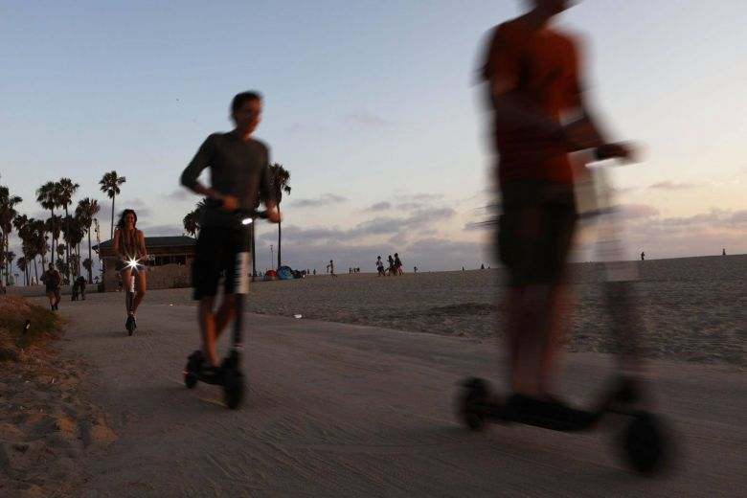
HYMN CH4 366 ‘Come into the streets with me!’
Words © 1992 by Hope Publishing Company Shirley Erena Murray
Music: English folk melody AA 22arr. CE Strange © 1983 Mrs MW Strange
Come into the streets with me!
Come to where the crowds will be,
see a strange and gentle king
on a donkey travelling.
REFRAIN: Come and follow my leader,
come and follow my leader,
Jesus Christ is riding by,
come and follow my leader!
All the people shout his name,
waving branches, sing his fame,
throw their coats upon his road,
glad to praise the Son of God. REFRAIN
If the soldiers draw their swords,
will we dare to sing these words,
be his friends for just a day,
cheer him on, then run away? REFRAIN
Jesus goes where things are rough,
Jesus knows when life is tough,
always comes to us, his friends,
so his story never ends. REFRAIN
Please remain standing for the affirmation
AFFIRMATION OF FAITH (you are invited to join in with as much of this as you honestly can)

With stark symbolism we celebrate this journey:
Waving palms suggest popularity and endorsement
but for Jesus these will fade as the week draws on.
He walks on however, does not cut and run.
Without such stark symbolism
We face our many journeys within life.
We may seek popularity and endorsement
they do not always come
or they fade as for Jesus that eventful week.

In this moment of truth,
we affirm our intention to always journey on
as far as we are humanly able.
In this moment of truth,
we affirm our intention not to cut and run
as far as we are humanly able
In this moment of truth we face our own fallibility
and express our desire
for the Spirit’s strength, support and courage
to bolster our human spirit
so we can stay the distance.

OFFERING PRAYER
Amen
We recognise and bless the gifts brought to the table, and those which wing
their way electronically from our banks to the church’s account.

LIFE IN THE COMMUNITY OF ST ANDREW’S
People share notices and visitors are welcomed. If you have a notice not already in the order of service, please move to the front row, ready to speak briefly from the lectern.
For the benefit of newcomers, please introduce yourself before you begin.

PRAYERS OF THE PEOPLE Catriona Cairns

CIRCLE OF PRAYER
We think today of the people of Nepal and the Hindu people in Nepal and throughout the world. In New Zealand, we remember those in Parliament, and today we name Todd Muller, (Bay of Plenty electorate) and Stuart Nash (Napier electorate). Here in the Central Presbytery, we pray for the leaders and people of - Knox Fitzroy Presbyterian Church and St Andrew's Presbyterian Church, New Plymouth.

PRAYER FOR ST ANDREW’S on card

HYMN ‘Through the crowds’
Words: © Palm Sunday 2018 Susan Jones
Tune: Blaenwern WOV 165(ii)
Through the crowds a donkey passes
Grey and humble, young and small
Makes its way among the masses
Carrying Jesus through it all;
Quietly, gently, rides the stranger
Loud and boisterous is the crowd
Calm and centred, into danger,
Sure his pathway to his shroud.

Symbols stand at every corner
Coats and donkeys, stones and palms
Raucous joy, no sadness or mourners
Spirits high, with ringing psalms;
Simple triumph is all their agenda
Welcoming a King above kings
Not a thought of evil offender
Streets with glad hosannas ring

In our lives we face such choices
Which the leader we will choose?
Here one whom the crowd rejoices
Over there, one bound to lose;
One has riches and prestige and power
One has only love to expend;
Every day and even each hour
We decide which we’ll befriend.

May we find the courage to ponder
Not the easy, but the best;
In our hearts make room for wonder
Find, through myst’ry, the truest quest
Which demands the fullest commitment
Life and love, possessions too
Heart and mind both fully recruited
All now making a journey true.

BLESSING

SUNG AMEN

THANK YOU Bruce Corkill
Our musician today

Unless otherwise specified all our music is used by permission CCLI Licence 341550
Words/music to new hymns and gathering statement, prayers and affirmation are original unless acknowledged. If Susan Jones is the worship leader any liturgy will have been written by her. These words can be used in other worship and small group situations without seeking permission. Please acknowledge the source.
AUDIO REFLECTIONS
Sunday reflections are usually available on our website.
http://www.standrews.org.nz/category/sunday-gathering

Wellington City Council now charges for weekend parking on the street. As well as that, there is a two hour parking limit. If you have parked on the street initially and are staying for an after-church activity,
it may be possible to move your car into the St Andrew’s/Braemar car park but please be careful that you do not block anyone in.

We welcome all visitors and invite you to stay for morning tea or coffee.
Please sign the visitors’ book at the back of the church.
We hope you enjoyed worshipping with us. At St Andrew’s we want you to feel at home—to join in with the activities of our community of faith, or to come and find your own spiritual place in your own time. If you would like more information about St Andrew’s or to explore becoming a member or associate member, please fill in one of the welcome leaflets (at the back of the church) and hand it to a minister or a welcoming team member.

GENEROUS GIVING
St Andrew’s depends on the generous giving of members and friends. If you would like to make a donation or support our work through planned giving, please contact our Parish Office or Treasurer. Bank account for donations is: St Andrews on The Terrace, BNZ Lambton Qy, 02-0534-0004022-02

ST ANDREW’S COMMUNITY NOTICES

APRIL AT ST ANDREW’S ON THE TERRACE
Lent
April 14 10am Lent Six Palm Sunday.

Holy Week
April 18 6pm Maundy Thursday Contemplative Communion
led by Susan Jones
This service is a partial re-enactment of the evening of the Last Supper. It will include hand washing as part of the service –participation in this is optional
April 19 10am Good Friday led by a team with Fiona McDougal and Sonia Groes Petrie, Women of the St Andrews Singers
Walking round the Stations of the Cross
During the Good Friday service any who wish are invited to walk round the Stations with those doing the Bible readings at each painting. Come for all or part of the way. We will gather at the right-hand side of the church after the introductory part of the service.
April 20 10am Holy Saturday A quiet hour of contemplation
The church will be open from 10am and at 10.30am we will begin an hour of silence interspersed with music and readings at quarter hour intervals till 11.30am, to keep vigil for Holy Saturday. The church will close at 12 noon
April 21 10am Easter Day St Andrew’s Singers. Gathering & Communion led by Susan Jones
Easter season
April 28 10am Easter 2 Gathering led by Jim Cunningham

NOTICE OF SPECIAL GENERAL MEETING ON 5 MAY
Parish Council is calling a short Special General Meeting after the service on 5 May 2019 at 11:45 am. The purpose of the meeting is to approve a specific technical requirement for our application to Presbytery and the Church Property Trustees in respect of a grant application to the Lotteries Environment and Heritage Committee to support the organ refurbishment project.

MINDFUL PEOPLE BUILD THE FUTURE
Sunday evenings: 5.30 – 7.00 pm April 14
Conference Rooms 1 & 2, 2nd Floor, St Andrew’s Centre, 30, The Terrace.
Cost: $40.00 for course or $15.00 per session. A four-week course providing practical meditation instructions and opportunities to discuss what meditation and mindfulness mean to us and how to use them in our lives. Registration: admin@satrs.org.nz.
Payment: online banking to: Bank account 38 012 0627 755 700 Or by cheque to SATRS, C/- P O Box 5203, Wellington 6140 For more information email: admin@satrs.org,nz

HELP IN THE CENTRE
Laetitia is interested in putting together a list of volunteers who wouldn’t mind helping out in the centre on an occasional basis, e.g. on busy afternoons or when staff are on leave. If you could help with setting up / packing down furniture, or tea and coffee set up please email Laetitia at office@standrews.org.nz

WALKING ROUND THE STATIONS OF THE CROSS ON GOOD FRIDAY
During the Good Friday service any who wish are invited to walk round the Stations alongside those doing the Bible readings at each painting. Come for all or part of the way. We will gather at the right hand side of the church after the introductory part of the service.
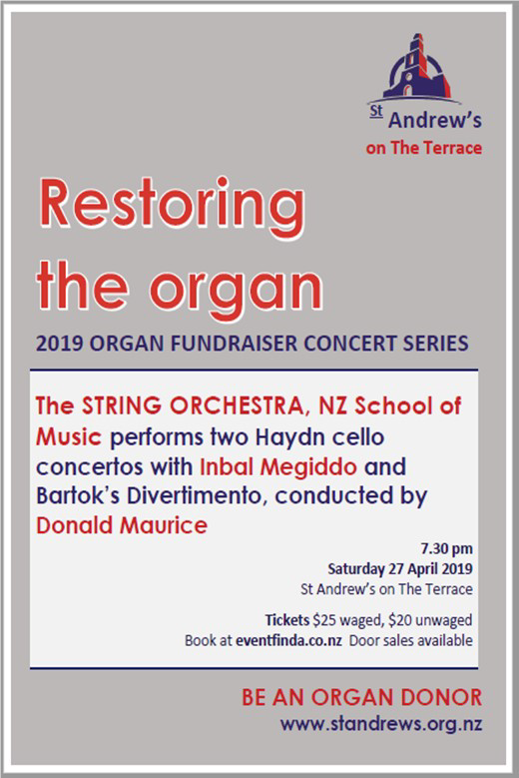
2019 ORGAN FUNDRAISING CONCERTS IN THE CHURCH
To remind: the first of these takes place on
Saturday 27 April at 7:30 in the church featuring the students and staff of the NZ School of Music at Victoria University of Wellington. This will be followed by Martin Riseley’s violin recitals on Friday 24 May and 7 June at 6:30 pm.
New for your diaries: Peter Franklin is organising three Sunday afternoon organ recitals for 16 June, 21 July and 11 August.

WIDER CHURCH AND COMMUNITY NOTICES
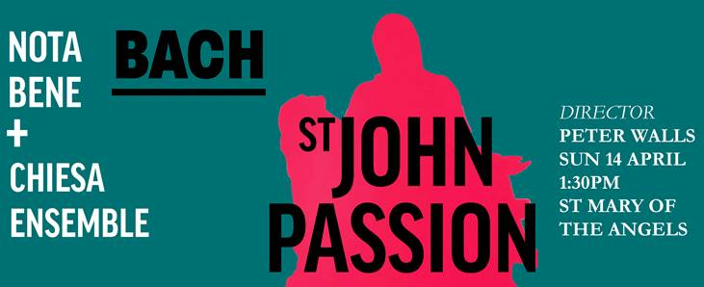
ST JOHN PASSION
A rare opportunity to experience Johann Sebastian Bach's wonderful setting of the St John Passion on Palm Sunday (14 April) at 1.30pm at St Mary of the Angels on Boulcott St.
Nota Bene (notabene.org.nz) and the Chiesa Ensemble are partnering once again to bring this choral masterpiece of Christian faith to Wellington audiences this Easter.
In addition to Chiesa Ensemble, they are joined by top notch soloists including Lachlan Craig (Evangelist), Simon Christie (Jesus), Maaike Christie-Beekman (alto) and Nicola Holt (soprano), as well as up-and-coming stars LJ Crichton (tenor) and Will King (bass).
Peter Walls ONZM, the Musical Director of Nota Bene, is keen to share his excitement and the history around this amazing work, and will be giving a pre-concert talk at 1pm. So come along to St Mary of the Angels on Sunday 14 April (Palm Sunday) for a performance to remember.
Tickets are $45 on the door for General Admission tickets. School children free.

LOCAL PEACE GRANTS DEADLINE: TUESDAY, 30 APRIL 2019
Quaker Peace & Service Aotearoa New Zealand (QPSANZ) The Religious Society of Friends - Te Haahi Tuuhauwiri. Applications are invited for grants up to $1,000 to assist with non-violent local peace work anywhere within Aotearoa New Zealand. - Applicants need not be Quakers. - Preference is given to work which is new and/or innovative in content - a one-off occasion (constructing a mobile peace stall; printing / advertising; inter-faith peace conference; peace / green fair; non-violence training day) or for a longer project (eg. restorative justice; a new organisation) The closing dates for applications are 30 April and 15 September each year, and grants are decided in May and September. Information about the Local Peace Grants and the application form are online at http://www.converge.org.nz/pma/lpg.htm Share this reminder on Facebook at https://www.facebook.com/PeaceMovementAotearoa/posts/2132310856816272
Enquiries: Local Peace Grants, c/o QPSANZ, 50 Glenross Street, Glenross, Dunedin 9011 or email stephodufresne@gmail.com
Information about Quakers is available at http://www.quaker.org.nz - please note that the details of the Local Peace Grants have not yet been updated on that website.

RAINBOW WELLINGTON
The Annual General Meeting of Rainbow Wellington is 6pm Tuesday 7th of May 2019, in Committee Room 1,Wellington City Council, (101 Wakefield St ). Nominations for the Rainbow Wellington Board are open. The nominee must be a RW member and be nominated by TWO other members. Send nominations to e-mail address below in advance of the meeting. General Business: The RW Board would appreciate any member proposing to raise notices of motion or items for discussion under General Business to send an indication to the Secretary at: rainbowwellington@gmail.com. The AGM is for RW Members. If you are still need to renew your membership go to the website or send a message to: RWmembership@gmail.com
GLORIA IN EXCELSIS REMEMBERING THE FALLEN
Come and enjoy the music of Bach, Elgar and Hollins and more. 'Gloria in Excelsis - Remembering the Fallen' is at St Mary of the Angels in Boulcott Street, Wellington on ANZAC Day, April 25th at 4.00 pm end entry is free.

SUNDAY ROSTERS
A folder with an outline of each duty is now kept on the back table. If you are unable to do your rostered duty please arrange a swap/substitute and inform the office. Thank you.

Thanks to this week’s volunteers
Welcoming | Brian and Lynette Burrell
Sound | Paul Satherley
Offering | TBA, Graham Howell
Coffee/tea | TBA, TBA, Sandra and Tony Kirby
Time with the Children | Susan Jones
Readings | Gillian Feist
Prayers of the People | Catriona Cairns
Musician | Bruce Corkill
Rainbow Room Helper | Ross Scott

On duty Good Friday 19 April
Welcoming | TBA
Sound | Tony Cowdry
Musician | Peter Franklin

On duty Easter Sunday 21 April
Welcoming | Graham Howell, Valerie Rhodes
Sound | Bronwyn White
Offering | Joan Tyler, Sonia Groes-Petrie
Coffee/tea | Gavin and Jenny Watson, Roger Jones
Time with the Children | Susan Jones
Readings | Lynne Dovey
Prayers of the People | Lois Robertson
Musician | Peter Franklin
Rainbow Room Helper | Linda Wilkins

This Week and Coming Events at St Andrew’s
Sunday 14 April 10am Sunday Gathering led by Susan Jones followed by community brunch in hall.
Tuesday 16 April 12.45pm Centering Prayer in the Centre
Wednesday 17 April Cuppa and a Chat from 10.30am in the Centre
Wednesday 17 April 12.15pm Lunchtime Concert – Maria Mo – piano, Beethoven: Waldstein sonata, Albeniz: Iberia, book 1.
Thursday 18 April 6.00pm Maundy Thursday Gathering in the church
Friday 19 April 10am Good Friday Gathering led by Fiona McDougal and Sonia Groes Petrie & team
Saturday 10am for a 10.30am – 11.30am hour of quiet
Sunday 21 April 10am Easter Sunday Gathering led by Susan Jones

MISSION STATEMENT OF ST ANDREW'S ON THE TERRACE

To create a lively, open Christian faith community,
to act for a just and peaceful world, and to be catalysts for discovery,
compassion and celebration in the capital.

MINISTRY AT ST ANDREW’S – THE TEAM
Minister | Susan Jones
Parish Council Convenor | Lynne Dovey
Treasurer | Paul Barber
Facilities Management Group | Sandra Kirby
Pastoral Convenors | Linda Wilkins, Maxine Cunningham, Brian Burrell and Pat Booth
Church Music Coordinator | Vivien Chiu
Theologian in Residence | Lloyd Geering
Presbytery Representative | Lois Robertson
Concert Coordinator | Marjan van Waardenberg
Social Justice Co-ordinator | Margaret Rushbrook
Rainbow Room Coordinator | Jules Collinson
Centre Manager | Laetitia Brunell
Office Administrator | Jillene Everett
Facilities Assistants | Julia Caulfield and Nick Lee
Roster Coordinator | Rosemary Lawrence

St Andrew’s on The Terrace
www.standrews.org.nz
30 The Terrace – P O Box 5203, Wellington 6145
Office Hours: 9 am – 5 pm Monday to Friday
Phone (04) 472-9211
office@standrews.org.nz

Rev Dr Susan Jones
Office: (04) 472-9376. Home: (04) 909-9612. Cell: 027-321-4870
minister@standrews.org.nz

