St Andrew’s on the Terrace Sunday 24 March 2019 Lent 3 Pride 3

Hebrew Bible Genesis 2: selected verses between v4 and v22
Adam and Eve
4 This is the account of the heavens and the earth when they were created, when the Lord God made the earth and the heavens. 5 Now no shrub had yet appeared on the earth and no plant had yet sprung up, for the Lord God had not sent rain on the earth and there was no one to work the ground, 6 but streams came up from the earth and watered the whole surface of the ground. 7 Then the Lord God formed an earth creature from the dust of the ground and breathed into its nostrils the breath of life, and the earth creature became a living being. 8 Now the Lord God had planted a garden in the east, in Eden; and there he put the creature he had formed. 9 The Lord God made all kinds of trees grow out of the ground—trees that were pleasing to the eye and good for food. In the middle of the garden were the tree of life and the tree of the knowledge of good and evil…
15 The Lord God took the earth creature and put it in the Garden of Eden to work it and take care of it… 18 The Lord God said, “It is not good for the earth creature to be alone. I will make a helper suitable for it.” 19 Now the Lord God had formed out of the ground all the wild animals and all the birds in the sky. He brought them to the earth creature to see what it would name them; and whatever the earth creature called each animal, that was its name. 20 So names were given to all the livestock, the birds in the sky and all the wild animals. But for the earth creature no suitable helper was found. 21 So the Lord God caused the creature to fall into a deep sleep; and while he was sleeping, he took one of its ribs and then closed up the place with flesh. 22 Then the Lord God made a woman from the rib he had taken out of the earth creature, and he brought her to the earth creature who was now a man.

Epistle Galatians 3: 23-29
Children of God
23 Before the coming of this faith, we were held in custody under the law, locked up until the faith that was to come would be revealed. 24 So the law was our guardian until Christ came that we might be justified by faith. 25 Now that this faith has come, we are no longer under a guardian. 26 So in Christ Jesus you are all children of God through faith, 27 for all of you who were baptized into Christ have clothed yourselves with Christ. 28 There is neither Jew nor Gentile, neither slave nor free, nor is there male and female, for you are all one in Christ Jesus. 29 If you belong to Christ, then you are Abraham’s seed, and heirs according to the promise.

Contemporary reading Matthew Vines from ‘The Gay Debate: The Bible and Homosexuality’ transcript of a talk on video on Matthew’s website: http://www.matthewvines.com/transcript/
In Matthew 7, in the Sermon on the Mount, Jesus warns against false teachers, and he offers a principle that can be used to test good teaching from bad teaching. By their fruit, you will recognize them, he says. Every good tree bears good fruit, but a bad tree bears bad fruit. A good tree cannot bear bad fruit, and a bad tree cannot bear good fruit. Good teachings, according to Jesus, have good consequences. That doesn’t mean that following Christian teaching will or should be easy, and in fact, many of Jesus’s commands are not easy at all –turning the other cheek, loving your enemies, laying down your life for your friends. But those are all profound acts of love that both reflect God’s love for us and that powerfully affirm the dignity and worth of human life and of human beings. Good teachings, even when they are very difficult, are not destructive to human dignity. They don’t lead to emotional and spiritual devastation, and to the loss of self-esteem and self-worth. But those have been the consequences for gay people of the traditional teaching on homosexuality. It has not borne good fruit in their lives, and it’s caused them incalculable pain and suffering. If we’re taking Jesus seriously that bad fruit cannot come from a good tree, then that should cause us to question whether the traditional teaching is correct.
Reflection for the Gathering 24 March 2019
The Big Bang theory of humanity involves a primordial soup of amino acids, morphing into single and then multi-celled life forms, which developed fins and gills, then legs and the ability to walk on dry land, then the ability to stand on two legs, to skip through just a few million years of evolution. Our human origins appear to lie within the Africa continent, though many areas of those origins remain shrouded in mystery as yet.
The scientifically untrained minds of the times when the first stories began to circulate about the origins of humankind, describe a god with fingers able to fashion clay into a figure, perhaps like the clay figures the story tellers saw children making or which they made themselves to illustrate their narratives. Then they had another theological problem - what to do to get an inanimate clay object breathing and walking and living like we do? Why, have the god breathe into that figure the Breath of Life! And so was the first human creature made – not a man according to the Hebrew, but ha’adamah, an earth creature.
This earth creature remains basically sexless until the differentiation of female from male occurs in Genesis 2:21-23. Only with the advent of sexuality does the term ha-'adam acquire the secondary meaning of "male"; but even then it is an ambiguous term.
This clarification aside, all of us are made, whether we believe by evolution or by a pottering God, much the same as each other. In either version of the story there are no special exceptions, or alternate models. One account is scientific in the post Enlightenment sense, the other account is scientific in the ancient, metaphoric, and allegoric sense. This later sense is undergirded by the theological idea that God made women and men in the image of God’s very Self. It’s a staggering claim.
In the sense that we say “you’re the image of your mother, or “you look just like your father” or “aren’t you like your grandmother?” we don’t always mean we look physically like our forbears, sometimes it is personality or values, or intelligence or a particular way of making a statement or telling a joke. I have often found it a rather spooky experience meeting the half grown child of a friend or relative whom I haven’t seen for a long time watching them smiling like their father or tossing their hair like their mother, or using a hand gesture that is completely familiar though I have only just met them.
My point is that in conventional theology, all human beings, whatever their identity or orientation are, in that theological way of thinking, made in the image of God. I don’t know whether that means we are exact copies in a theological sense, or that together as a total population when added together we make up the wholeness of the Holy One. And do we look like God or sound like God or think like God – in what way are we that image? Even the theologians don’t know that, I asked just last Friday at the ministers’ day and didn’t get a very satisfactory answer.
We are however, all human.
As I said with the children, we are all contributors to the wide rainbow of life. We add our own colouration to the whole. We contribute the dark blue or forest green or regal violet or the lemon yellow or perhaps the warm orange and scary red.
That means here in the church or out there in society, we need everyone be present. Everyone to be able to function in the world with vigour and verve – otherwise our world greys off into mediocrity and obscurity. We need you and you need us. This is akin to the “you are us” slogan which has been prevalent this week. Our society is not complete if Muslims are missing. Our society is not complete if the lgbtqi community is absent.
All those little clay figures made in the Creator God’s potters house, all have potential. And because we are all different, we each have different potential. It doesn’t matter what shape, size, colour, orientation or race we are, we all have human potential. And the goal of being human is to fulfil that potential as best we can. If we are gay or lesbian, or bisexual, let’s be the best at that which we can be.
If we are cisgender, happy with the biological sex we were born with, let’s do that well. If we are straight, let’s be the best straight people we can be. If we are lesbian, gay or bisexual, trasn or intersex let’s do that superbly.
And because this is a Christian Community, not a bunch of disparate individuals sitting alone and isolated from each other; because we are a community, it is our role as a community to help each other reach that human potential which is in each one of us. We each need something different to reach that different potential which lies within us waiting to be realised. Some may need simple friendship, others some funding, others, more recognition, others will need a comrade fighting alongside them, others just want a chance to be in a place where it is OK to be exactly who you are. That was the goal of the Harvest Cafes on the 9th and 23rd of March. It was the goal of the Spiritual Gathering on Tuesday the 19th. It has been goal of St Andrew’s for many years now, offering a space where everyone can reach their full potential.
So (first point) we are human, all of us in our diversity.
Second point - we are a rainbow of diversity, multicoloured and multi-orientated and multi-identity.
You know, the joke is on the heterosexuals when it comes to flags! Someone showed me the other day a set of pictures of the various flags which have been devised in their exploration of orientation and identity. The one called the heterosexual pride flag was just shades of grey – no colour at all!. Shows the dominant group in a different light from how they might usually see themselves! I thought it was a clever statement by someone.
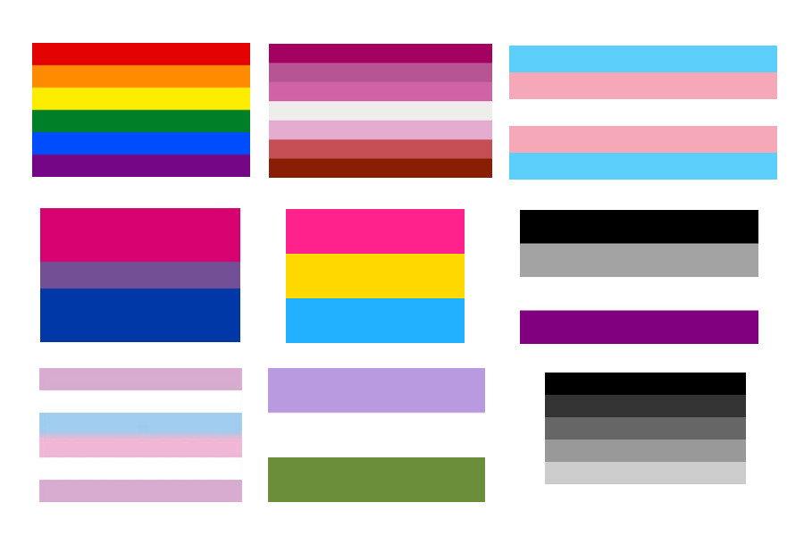
(From left top to bottom right) row 1 Gay pride; lesbian; transgender; Row 2 bisexual; pangender; asexual; Row 3 intersex; genderqueer and heterosexual pride flags.
Sadly, the rest of New Zealand, secular as it is in the main, with those of ‘no religion’ being the largest group in the last census, has less trouble than the church with the concept of a group in society being human and rainbow.
I discovered watching the interfaith group planning events for the pride festival how small and fragile is the group which owns all three of the descriptors; Human, Rainbow and Christian. This is where the church does not realise the contradiction in which it has placed itself by excluding some people – how it apparently good theological tre is producing bad fruit. The hope of the Christian message – Jesus’ words to the listening crowds - was that his followers would be known by their love, and that the welcome he was issuing to the kingdom of God was for every human being.
So getting trifecta is possible. Humans of the rainbow community also belong in the Christian community if they chose to follow the Jesus Way. And here, even if you don’t choose to do that but still want to be part of this community you are also welcome. As I said last week, the point is not so much who is in any relationship but the quality of the connection. All of us whatever colour our flag, are urged in different ways in scripture to be loving, nonviolent, patient, loving and kind, faithful and to offer mutual support to one another.
The person who wrote to the tiny church in Galatia in the first century was gender blind and orientation free. We can see from, the reading from Galatians that he (it probably was a he), didn’t see that there were any groups left out of the deal of the Jesus Way. Slaves and their owners were welcome, men and women were welcome, Jews were welcome and so were Greeks. In true rhetorical style, the writer stops at three pairs of groups of people which he names, but had he known the words we use today, he would have written something like this in those few verses:
26 So in Christ Jesus you are all children of God through faith, 27 for all of you who were baptized into Christ have clothed yourselves with Christ. 28 There is neither Jew nor Gentile, neither slave nor free, nor is there male and female, nor is there cis or trans, gay or straight, gender fixed or gender fluid, for you are all one in Christ Jesus.
Because we have been backed into our respective corners we tend to take on hard and fast identities – gay- straight, cisgender- transgender, but whatever those identities and orientations are, I get the sense here that the writer is telling us that in the divine framework of the world, we are all simply members of the whole family, children of the community of faith, siblings, cousins, rellies of the same bloodline; we are the human race.
In a now classic movie “You’ve Got Mail” 30 something year old Tom Hank introduces his 10 year old aunt and his 4 year old brother, announcing “We are an American family”. In the same way, all the many varieties of us make up the human race.
Who then would we dare turn away? Let’s make sure that our teaching comes from a good theologically sound tree which produces good theologically sound fruit!
I look forward to the day when the orchard of God is flourishing with good strong, fruit trees laden with delicious fruit of many kinds
I look forward to a day when there will be no need for a reflection like this anymore.
I look forward to a day when it will be taken for granted that we are all one kin, all loved and all embraced in the divine heart whether we are in the rainbow or not.
So may it be!
Susan Jones 027 321 4870 04 909 9612 minister@standrews.org.nz

‘GENESIS FROM EVE'S POINT OF VIEW’, By Pamela Milne March 26, 1989 “When the woman is created, it is as an 'ezer k-negdo -- an expression which does not have the pejorative sense carried by the English "helper" or "helpmate." The sense of 'ezer is expressed better by the phrase "a companion corresponding to it." The implied relation is beneficial and does not connote inferiority. In fact, the same Hebrew word is used to describe God (see Exodus 18:4; Deuteronomy 33:7; Psalm 33:20).” https://www.washingtonpost.com/archive/opinions/1989/03/26/genesis-from-eves-point-of-view/dc371184-1f4c-4142-ac2d-d5efee72a0da/?noredirect=on&utm_term=.dfde46a5649a

