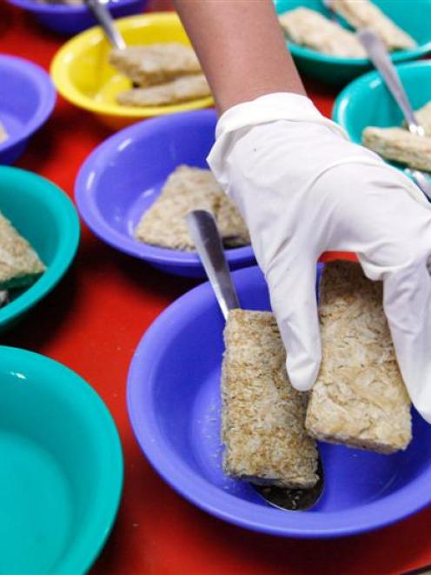

St Andrew’s
on The Terrace invites you
to participate
in

the second of two evenings
of pre-election
discussion and debate
Second forum: Fair Income levels for All
Date: Tuesday 15 August, 2017
Time: 5:30 – 7 pm
Topic: How do we ensure every family and individual in New Zealand has a fair income so they can participate well in society?

Join us on your way home from work
Bring your questions for the panel
Contribute your ideas

Panel members:
Chair: Lyndy McIntyre, Living Wage
Paul Barber, NZ Council of Christian Social Services
Max Rashbrooke, Journalist and Author.
Regina Tito-Campbell, DCM Outreach Worker.

Phone 472 9211
Hato Anaru o Te Parehua
Founded 1840

Email: reservations@standrews.org.nz
www.standrews.org.nz

St Andrew’s
on The Terrace invites you
to participate
in

the second of two evenings
of pre-election
discussion and debate
Second forum: Fair Income levels for All
Date: Tuesday 15 August, 2017
Time: 5:30 – 7 pm
Topic: How do we ensure every family and individual in New Zealand has a fair income so they can participate well in society?

Join us on your way home from work
Bring your questions for the panel
Contribute your ideas

Panel members:
Chair: Lyndy McIntyre, Living Wage
Paul Barber (NZ Council of Christian Social Services)
Max Rashbrooke (Journalist and Author)
Regina Tito-Campbell (DCM Outreach Worker)

Phone 472 9211
Hato Anaru o Te Parehua
Founded 1840

Email: reservations@standrews.org.nz
www.standrews.org.nz

St Andrew’s
on The Terrace invites you
to participate
in

the second of two evenings
of pre-election
discussion and debate
Second forum: Fair Income levels for All
Date: Tuesday 15 August, 2017
Time: 5:30 – 7 pm
Topic: How do we ensure every family and individual in New Zealand has a fair income so they can participate well in society?

Join us on your way home from work
Bring your questions for the panel
Contribute your ideas

Panel members:
Chair: Lyndy McIntyre, Living Wage
Paul Barber (NZ Council of Christian Social Services)
Max Rashbrooke (Journalist and Author)
Regina Tito-Campbell (DCM Outreach Worker)

Phone 472 9211
Hato Anaru o Te Parehua
Founded 1840

Email: reservations@standrews.org.nz
www.standrews.org.nz

St Andrew’s
on The Terrace invites you
to participate
in

the second of two evenings
of pre-election
discussion and debate
Second forum: Fair Income levels for All
Date: Tuesday 15 August, 2017
Time: 5:30 – 7 pm
Topic: How do we ensure every family and individual in New Zealand has a fair income so they can participate well in society?

Join us on your way home from work
Bring your questions for the panel
Contribute your ideas

Panel members:
Chair: Lyndy McIntyre, Living Wage
Paul Barber (NZ Council of Christian Social Services)
Max Rashbrooke (Journalist and Author)
Regina Tito-Campbell (DCM Outreach Worker)

Phone 472 9211
Hato Anaru o Te Parehua
Founded 1840

Email: reservations@standrews.org.nz
www.standrews.org.nz

