Classical Guitarists from the New Zealand School of Music, Victoria University
Joel Baldwin, Emma Sandford, Lucinda Ng, Amber Madriaga, Rameka Tamaki, Oliver Fetherston, Toby Chadwick, Megan Robson, Krishn Naicker-Duggal.

Wednesday Lunchtime Concerts providing lunchtime music in the heart of the city since 1974
St Andrew’s on The Terrace WELLINGTON
10

05
17

12.15pm
Welcome
It is wonderful that you have come. Thank you.
We want your experience today to be the best that it can be and would appreciate you taking a moment to read the following before the concert commences.
Keep safe by locating the exit nearest to your seat.
In the event of an earthquake, our recommendation is to Drop, Cover and Hold.
Bon appetit! You are welcome to have your lunch during the performance. Switching your cell phone to silent is important to the performers and other members of the audience.
Your support by way of a donation and telling others about the concerts would be fantastic and very much appreciated. It does make a difference.
If you wish to photograph or video today’s concert, please ask for permission from the performer(s) before the concert begins. This is important.
We invite you now to sit back, relax and enjoy the concert.
Our Mission is to create a lively, open Christian faith community, to act for a just and peaceful world, and to be catalysts for discovery, compassion and celebration in the capital.
These lunchtime concerts are advertised through Radio New Zealand Concert’s Live Diary at around 8.10 am on the day of the concert, and listed on St Andrew’s website.
To be placed on the email circulation list for concert information, please email Marjan on marjan@marjan.co.nz
Check out the noticeboards in the foyer each time you come.

Programme
Grand Jig (guitar orchestra) by Mark Houghton (b.1959)
Born in Liverpool, Mark began playing guitar at the age of seven and studied classical guitar with Stanley Yates, as well as receiving private tuition from Stepan Rak on the performance of Rak's music. Grand Jig is scored for eight guitars and as the title suggests, is in 6/8 meter in keeping with the characteristics of the jig dance.

Cuban Landscape with Rain (guitar orchestra) by Leo Brouwer (b.1939)
Progressive Cuban composer and conductor Leo Brouwer was encouraged musically by his father, an amateur guitarist, and began playing the guitar when he was 13. He was the first Cuban composer to use aleatory forms, of which this piece is an example – presenting a musical impression of the approach and passing of a rainstorm.

Sanzen-in (guitar duet) by Andrew York (b.1958) played by Oliver Fetherston and Rameka Tamaki
Andrew York is an American classical guitarist, lutenist, and composer. He has published over 50 works for guitar, as solos, duos, trios, quartets, and larger ensemble settings. Sanzen-in Temple is the main attraction of a rural town north of Kyoto, named Ohara; it is a temple of the Tendai sect of Japanese Buddhism. The temple’s moss garden is said to have a tranquil atmosphere, with a number of amusing stone statues that peek out from the moss bed.
York’s Sanzen-in is a composition for two guitars. It was written for the Japanese guitarist, Dai Kimura, after the composer paid a visit to the aforementioned temple in June 2000. It captures the tranquil, reverent atmosphere of Sanzen-in and its surroundings. The chanting of mantras, a central esoteric ritual in Tendai Buddhism, may possibly be heard in the repetitive nature of the accompaniment and structure.

Sakura No Hana Variations for Two Guitars by Marek Pasieczny (1980)* played by Emma Sandford and Joel Baldwin
Internationally award winning guitarist and composer Marek Pasieczny is one of the most popular contemporary composers writing for the guitar worldwide. His works often explore new and exciting ways to use the instrument through extended techniques, extreme tone colours, dynamics, and tonal ranges, always while serving the musical content.
Sakura, meaning ‘cherry blossoms’ is a traditional Japanese folk song depicting spring, the season of cherry blossoms. It is known internationally as a song representative of Japan, and due to its simplistic melody made up of just five notes, many composers have been inspired to write variations on the theme. Pasieczny uses this simplicity to his advantage, exemplifying his skill in revealing the incredible flexibility of the guitar while staying true to the original melody.

Nebulae for guitar orchestra by Olga Amelkina-Vera (b. 1978)
Composer and guitarist Olga Amelkina-Vera grew up in Belarus and moved to the United States in 1997. She earned her Bachelor of Arts degree Summa Cum Laude from the University of St. Thomas in Houston, and her Master of Music and Doctor of Musical Arts degrees in guitar performance with a related field in music history from the University of North Texas.
From the composer: I wanted to write a guitar ensemble piece that used some elements of minimalism, but would not be strictly minimalistic. Since I am fascinated by all things about space, I chose “Nebulae” as an evocative title which reflects the “nebulous” effect of multiple superimposed guitar ostinatos.

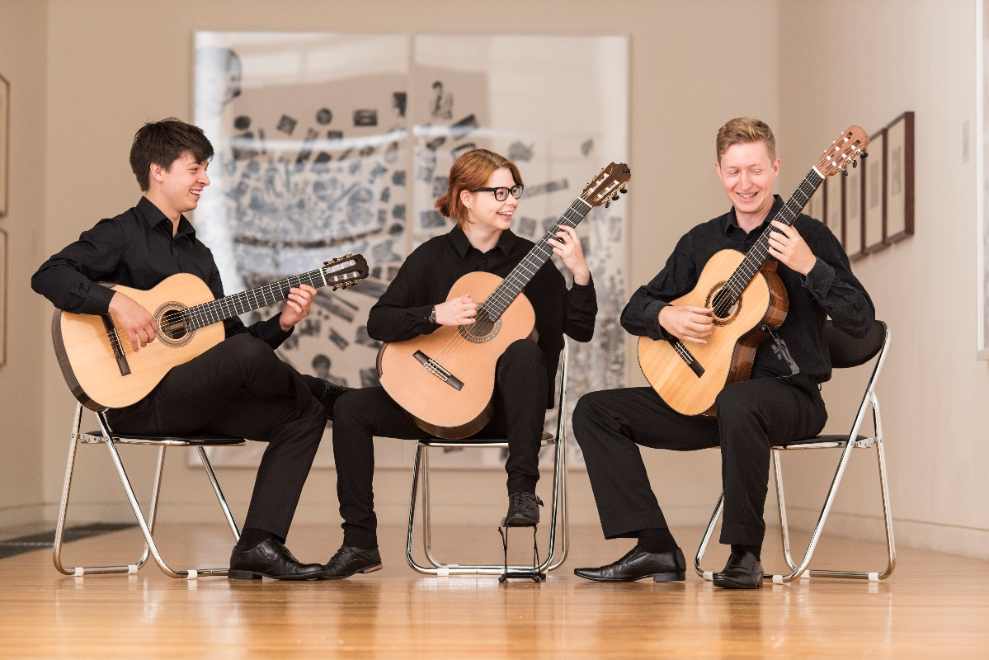

Special thanks to Marjan and staff at St Andrew’s for providing this important concert opportunity for young players (in such a great venue). Many thanks to the audience for coming! For more information about the guitar program at the New Zealand School of Music, please contact Dr Jane Curry – jane.curry@nzsm.ac.nz

Contact us

e | wednesday@standrews.org.nz p | 04-472-9211 w | www.standrews.org.nz
We thank our generous supporters

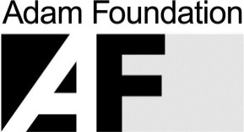
and all those who donate weekly

Check out the What’s On and Concerts section on our website www.standrews.org.nz

The only place you'll find reviews of these concerts (and almost all other classical music in Greater Wellington) is at www.middle-c.org
Use it to find out what's coming up in classical music performance through the website's Coming Events listings

Coming Up

17th May Wellington Guitar Duo – Jane Curry and Owen Moriarty

18th May (Thursday) Euphonium and Piano – Euphonium Concert by Anthony Ritchie
Buzz Newton - Euphonium, Kristen Robertson – Piano.

24th May Woodwind ensemble of the NZSM

31st May NZSM piano Students
7th June Flute Soloist
14th June Donald Maurice and others - Music featuring the viola d’amore

