Hato Anaru o Te Parehua
Founded 1840
Carols for Christmas
From the Gospel of John, Chapter one
In the beginning was the Word, and the Word was with God,
and the Word was God. He was with God in the beginning.
Through him all things were made;
without him nothing was made that has been made.
In him was life, and that life was the light of humankind.
The light shines in the darkness,
and the darkness has not overcome it.
The true light that gives light to everyone
was coming into the world.
He was in the world,
and though the world was made through him,
the world did not recognize him.
He came to that which was his own, but his own did not receive him. Yet to all who did receive him,
to those who believed in his name,
he gave the right to become children of God
children born not of natural descent, nor of human decision or a husband’s will, but born of God.
The Word became flesh and made his dwelling among us.
We have seen his glory,
the glory of the one and only Son,
who came … full of grace and truth.

ONCE IN ROYAL DAVID’S CITY 237 With One Voice
Words: Cecil Frances Alexander (1818-95) alt
Music: Henry John Gauntlett (1805-76)

Once in royal David’s city,
Stood a lowly cattle shed,
Where a mother laid her baby,
In a manger for his bed:
Mary was that mother mild,
Jesus Christ, her little child.
He came down to earth from heaven,
Who is God and Lord of all,
And his shelter was a stable,
And his cradle was a stall:
With the poor, and mean, and lowly,
Lived on earth our Saviour holy.
He became our lifehood’s pattern
Loving, healing, so he grew
All he met he welcomed freely
Now he welcomes me and you
Round him now we all can meet
diverse people he does greet.
And our world at last shall see him,
Through his own redeeming style;
For that child so dear and gentle,
Walks with all, the second mile
With compassion we must live
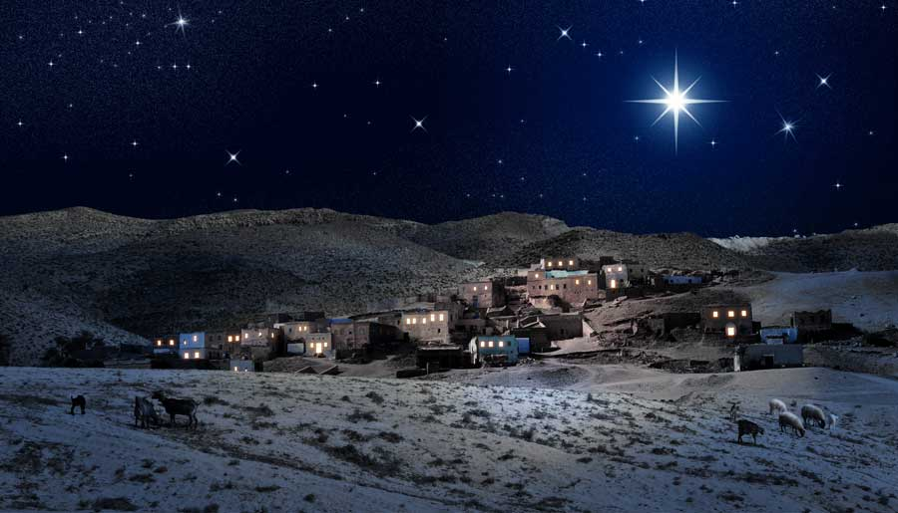
his love to all people give.

O LITTLE TOWN OF BETHLEHEM 240 With One Voice
Words: Phillips Brooks (1835-93)
Music: Forest Green (English trad.)

O little town of Bethlehem, how still we see you lie!
Above your deep and dreamless sleep the silent stars go by:
yet in the dark streets shines out the everlasting Light;
the hopes and fears of all the years are met in you tonight.

For Christ is born of Mary and gathered all above
While mortals sleep, the angels keep their watch of wondering love
O morning stars together proclaim the holy birth
And praises sing, O let them ring! And Peace to all on earth!

How silently, how silently, the wondrous gift is given!
So God imparts to human hearts blessings made in heaven
No ear may hear his coming, but in this world below
Where meek souls will receive him, still the Christ is sure to go

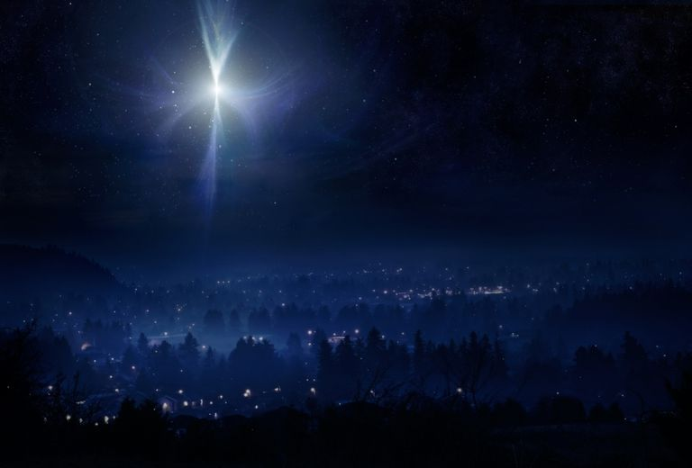

WHILE SHEPHERDS WATCHED THEIR FLOCKS BY NIGHT
223 (i) With One Voice
Words: Nahum Tate (1652-1715) alt.
Music: Winchester Old
While shepherds watched their flocks by night,
All seated on the ground,
The angel of the Lord came down,
And glory shone around
"Fear not," said he, for mighty dread
Had seized their troubled minds;
"Glad tidings of great joy I bring
To you and humankind
"To you, in David's town, this day,
Is born of David's line
A Saviour, who is Christ the Lord;
And this shall be the sign
The heavenly Babe you there shall find
To human view displayed,
All meanly wrapped in swaddling-clothes
And in a manger laid
Thus spake the seraph and forthwith
Appeared a shining throng
Of angels, praising God, and thus
Addressed their joyful song:
"All glory be to God on high,
And to the earth be peace;
Good will henceforth from Heaven to men
Begin and never cease.”

NATIVITY Peter Cape
They were set for home but the horse went lame
and the rain came pelting down out of the sky.
Joe saw the hut and he went to look,
and he said “she’s old, but she’ll keep you dry.”

So her boy was born in a roadman’s shack,
by the light of a lamp that would hardly burn.
She wrapped him up in her hubby’s coat,
and laid him down on a bed of fern.

Then they came riding out of the night,
and this is the thing that she’ll always swear,
as they took off their hats and came into the light,
they knew they were going to find her there.

She sat at the edge of the fernstalk bed,
and she watched, but she didn’t understand,
while they put those bundles by the baby’s head,
that river nugget into his hand.

Then she watched as they went through the open door,
weary as men who have ridden too far.
And the rain eased off and the low cloud broke,
and through the gap shone a single star

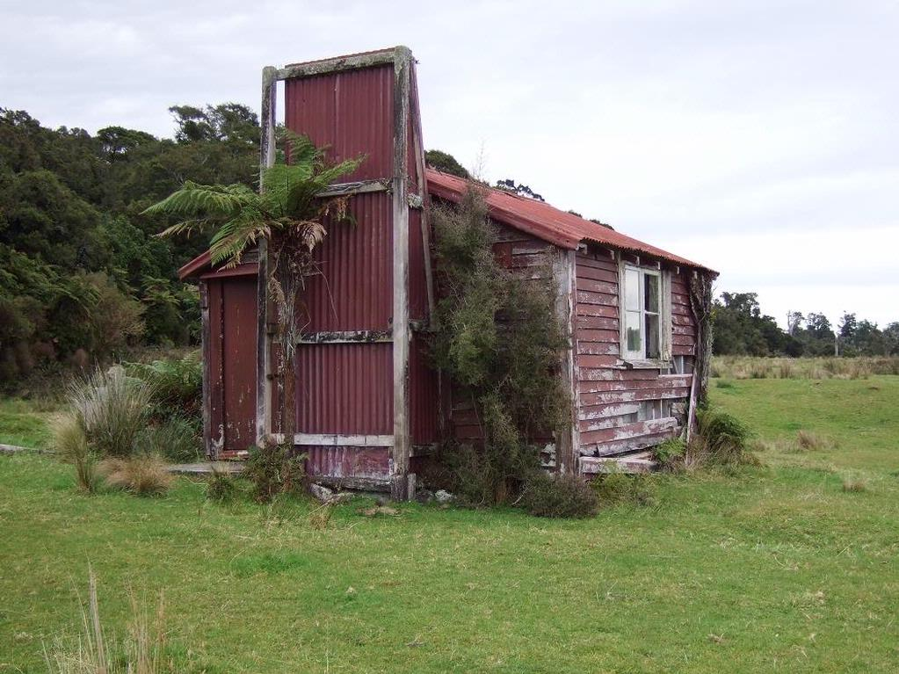

YOU ARE BORN IN US AGAIN 52 Carol our Christmas
Words & Music © 1996 Mark Wilson
Music arr. © Shona Murray. Descant © Colin Gibson
All rights reserved. Reprinted under One License #623996
You are born in us again.
Like the warmth of the summer wind you come,
to melt away the icicles of vanity and pride;
you come to blow the very doors of loving open wide.
Like the warmth of the summer wind you come, (repeat last line)

You are born in us again.
Like the scent of the summer rain you come.
You come to quench the thirsty and to freshen up the land;
you come to clean away the dust that’s settled in our hand.
Like the scent of summer rain you come, (repeat last line)

You are born in us again.
Like the light of the summer sun you come,
to give light to the places that have never seen the Son:
you come now to embrace us, you’re the holy, holy one.
Like the light of the summer sun you come, (repeat last line)

CAROL OUR CHRISTMAS 7 Carol our Christmas
Words: © 1986 Shirley Erena Murray
Music by Colin Gibson. Music © 1992 Hope Publishing Co

Carol our Christmas, an upside down Christmas;
snow is not falling and trees are not bare.
Carol the summer, and welcome the Christ child,
warm in our sunshine and sweetness of air.
Sing of the gold and the green and the sparkle,
Water and river and lure of the beach.
Sing in the happiness of open spaces,
Sing a nativity summer can reach!
Shepherds and musterers move over hillsides.
Finding not angels but sheep to be shorn;
Wise ones make journeys whatever the season.
Searching for signs of the truth to be born.
Right side up Christmas belongs to the universe,
made in the moment a woman gives birth;
hope is the Jesus gift, love is the offering,
everywhere, anywhere here on the earth.

Repeat verse one
WHERE IS THE ROOM? 48 Carol our Christmas
Words: ©1992 Shirley Erena Murray
Music: © 1993 David Dell

Where is the room,
where is the house of Christmas?
Where shall we welcome Jesus,
where are the signs of home?
where are the signs of home?
Let Christ have space,
place at the heart of living,
centre for birth’s new breathing,
cradle for hope and peace,
cradle for hope and peace.
Let there be room,
room for the friend and stranger,
room without hurt or anger,
room for whoever come,
room for whoever come.
Let love be here,
love from the Christmas stable,
love at our open table,
love to be shared all year,
love to be shared all year.

TE HARINUI 31 Carol our Christmas
Words & Music: © 1993 Willow Macky
All rights reserved. Reprinted under One License #623996

Not on a snowy night
By star or candlelight
Nor by an angel band
There came to our dear land
Te Harinui, Te Harinui
Te Hari-nu-i , Glad tid-ings of great joy
But on a summer day
Within a quiet bay
The Maori people heard
The great and glorious word
The people gathered round
Upon the grassy ground
And heard the preacher say
I bring to you this day
Now in this blessed land
United heart and hand
We praise the glorious birth
And sing to all the earth
SILENT NIGHT 236 With One Voice
Words: Joseph Mohr (1792-1848)
Music: Franz Xaver Gruber (1787-1863)

Silent night, holy night: all is calm, all is bright
round the loving mother and child, holy infant so tender and mild,
sleep in heavenly peace, sleep in heavenly peace

Silent night, holy night: shepherds quake at the sight;
glories stream from heaven afar, heavenly hosts sing
‘Alleluia’; Christ the Saviour is born, Christ the Saviour is born.

Silent night, holy night: wondrous star, lend your light;
with the angels let us sing ‘Alleluia to our King’;
Christ our Saviour is born, Christ our Saviour is born.

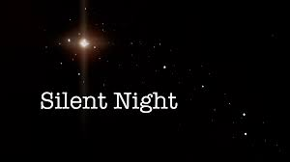
IN THE BLEAK MIDWINTER 305 Church Hymnal 4TH ed.
Words: Christina Rosetti (1830-1894)
Music: Gustav Holst (1874-1934)

In the bleak mid-winter frosty wind made moan;
Earth stood hard as iron, water like a stone;
Snow had fallen, snow on snow,
Snow on snow,
In the bleak mid-winter, long ago.
Our God, heaven can’t hold Him nor earth sustain,
Heaven and earth shall flee away when He comes to reign:
In the bleak mid-winter
A stable-place sufficed
The Lord God Almighty — Jesus Christ.
What can I give Him, poor as I am? —
If I were a Shepherd I would bring a lamb;
If I were a Wise Man
I would do my part, —
Yet what I can I give Him, —Give my heart.

HARK THE HERALD ANGELS SING 227 With One Voice
Words: Charles Wesley (1707-88) alt.
Music: Felix Mendelssohn(1809-47)

Hark! The herald angels sing
glory to the newborn king,
peace on earth and mercy mild,
God and sinners reconciled.
Joyful, all the nations rise,
join the triumph of the skies;
with the angelic host proclaim,
‘Christ is born in Bethlehem.’
Hark! the herald angels sing, Glory to the newborn king.

Mild he lays his glory by,
born that we no more may die,
born to live as one with earth,
born to give us second birth.
Hail the heaven-born prince of peace!
Hail the son of righteousness!
Light and life to all he brings,
risen with healing in his wings.
Hark! The herald angels sing, Glory to the newborn king.

Unless otherwise specified, all texts are reprinted by permission CCLI Licence # 341550.

