Historical Timeline of the Reformation in Scotland & England

Background Context from 14th and 15th centuries:

14th century

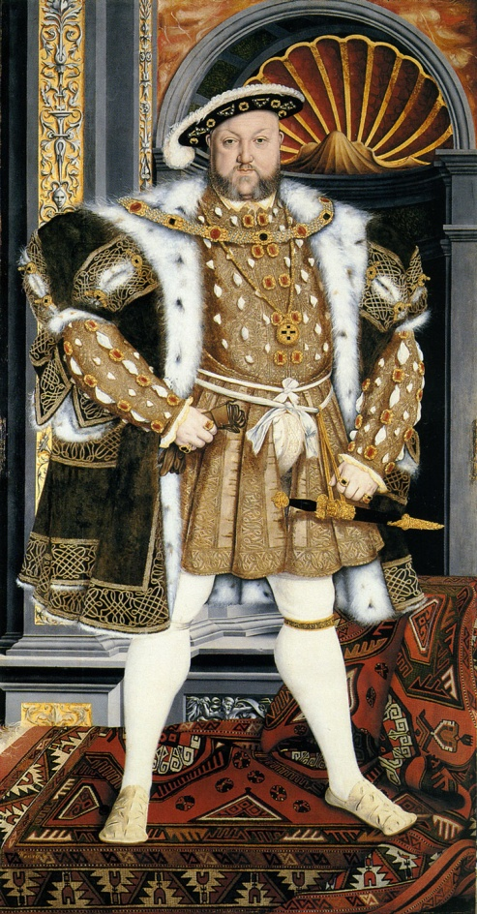
1305 William Wallace executed by the English for treason
1314 Battle of Bannockburn, Scotland won over England
1328 Treaty of Edinburg-Northampton recognises Scottish independence
1348 The Black Death arrives in England
1356 First battle of the Hundred Years’ War between England and France
1381 Peasants’ Revolt – (Wat Tyler’s Rebellion) major uprising over England led by Wat Tyler
1382 Wycliffe’s New Testament in Middle English begins to appear in print

15th century

1403 Battle of Shrewsbury (putting down of a rebellion against Henry IV)
1415 Battle of Agincourt (part of 100 Years War); Jan Hus burned at the stake in Europe
1484 Henry VII seizes the crown.
1485 Wars of the Roses end
Henry VIII

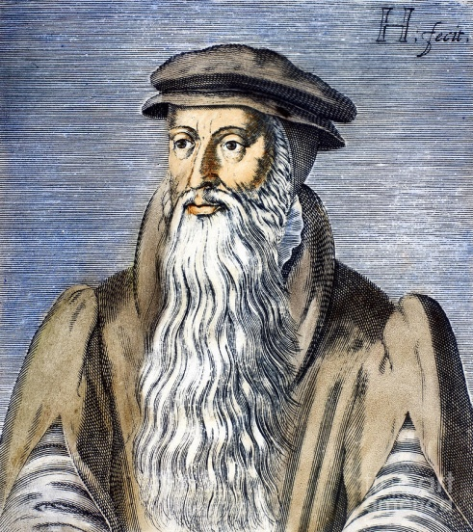
16th century
1513 Battle of Flodden, invading England, James IV of Scotland and thousands of Scots killed when defeated by England;
John Knox born
1517 Luther publishes his 95 theses for debate
1521 Lutheran writings begin to circulate in England
1526 Lord Chancellor Cardinal Wolsey orders burning of Lutheran books
John Knox
1533 Henry VII severs ties with Catholic Church, declares himself head of Church in England; Elizabeth I born
1535 Thomas More & Cardinal John Fisher executed by Henry VIII for their continuing allegiance to the Catholic Church.

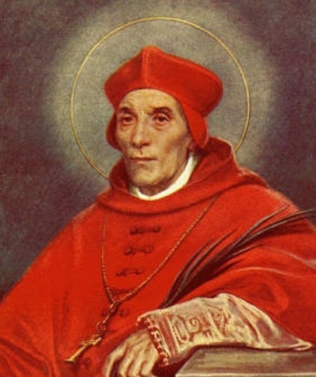
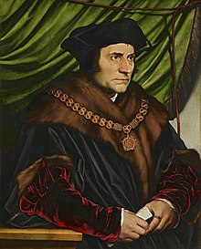
Lord Chancellor Thomas More Cardinal John Fisher

1536 William Tyndale (Protestant) executed in Antwerp;
Henry VIII issues the Dissolution of the Monastries; monastries sacked
1546 John Knox (Scotland) embraces Reformation ideas influenced by George Wishart being burned at the stake in this year
1547/9Knox confined in French galley ships; Henry VII dies; succeeded eventually by his Catholic daughter Mary who deposes Lady Jane Grey.
1549 Prayer Book Rebellion in southwest England;
John Knox goes into exile in England 1549-1554
1553 Act Against Sectaries makes Puritanism an offence in England. Puritans were English protestant reformers, some of whom became part of the later 1620 Mayflower immigration to America
1554/6 Knox travels to Geneva, Frankfurt and Scotland
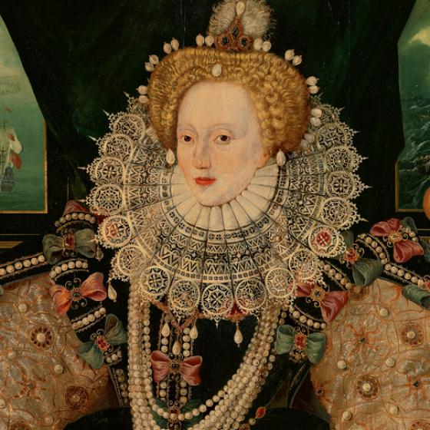
1556 Knox returns to Geneva

1558 Elizabeth I ascends the throne of England
1559 Act of Supremacy makes Elizabeth the Supreme Governor of the Church in England
1559/60Revolution in Scotland and end of the Regency of Mary de Guise for Mary Queen of Scots.

Elizabeth I, Supreme Governor, Church of England
1560/1John Knox recalled to Scotland and Scots’ Confession and First Book of
Discipline approved by Scottish Parliament (Scotland officially becomes Protestant)

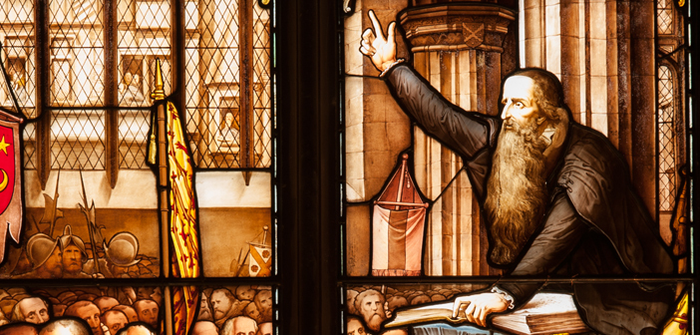
John Knox preaching at St Giles’ Cathedral (window in St Giles’)

1561/4John Knox and Mary, Queen of Scots clash
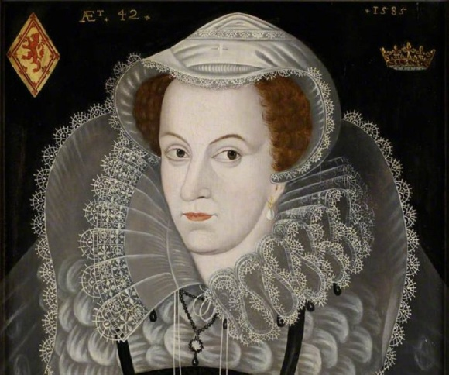

Mary, Queen of Scots

1571 Act Prohibiting Papal Bulls (documents) from Rome issued
1572 John Knox dies
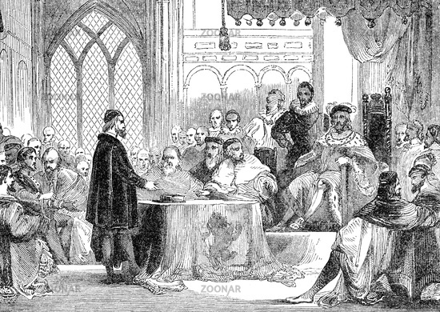
1578 Andrew Melville, as Moderator of General Assembly, took part in organising the Presbyterian method; Second Book of Discipline placed church leadership in hands of groups of elected church leaders, in presbyteries, synods and general assembly.

Andrew Melville
disputing the role of bishops

1585 Roanoake Colony formed in American, an attempt to create British colony
1588 Spanish Armada defeated
1589 English counter armada defeated by Spain
1593 Acts against Papists issued

17th century
1601 Elizabeth I dies, succeeded by James VI of Scotland who becomes James I of England uniting crowns but not parliaments of Scot & Eng; tolerant of Catholics, prefers bishops in churches
1605 Gunpowder Plot, Guy Fawkes and other Catholic associates conspire to blow up James VI & I and English Parliament
1607 Jamestown, Virginia, first successful British colony in the Americas
1618 Walter Raleigh executed
1639 Bishops’ Wars – English-Scottish wars lasting till 1640
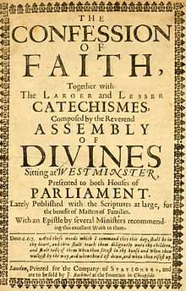
1640 Long Parliament – parliament convened in England
1642 English Civil War begins
1646 Westminster Confession adopted by Scottish parliament but not the English
1649 Trial and execution of Charles I
1649 Interregnum began with the First Commonwealth
1653 the Protectorate under Oliver Cromwell and later Richard Cromwell
1659 Second Commonwealth – period of great political instability
1660 Restoration of the Monarchy
1666 Great Fire of London
1688 ‘Glorious Revolution’, overthrow of James II by English Parliamentarians with William II of Orange-Nassau (Protestant)
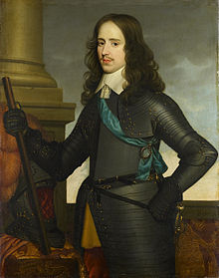

1707 Presbyterian church government ensured in Scotland by the Acts of Union which created the Kingdom of Great Britain.

