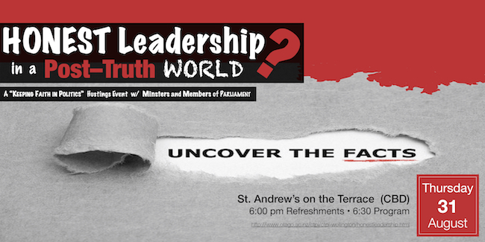
http://www.otago.ac.nz/ctpi/ctpi-wellington/honestleadership.html
www.standrews.org.nz

A Keeping Faith in Politics Hustings
We live in a “post-truth” world dominated by “fake news.” Anyone with a Twitter account is a pundit. Everyone with a blog is an expert. If our challenge in the past was having too little information, our challenge now is having too much information. There are facts and figures at our fingertips, but are they reliable? Our leaders are more accessible to us than ever, but are they truthful? How can citizens, cut through the spin and get to the bottom of things?
Spend an hour with Megan Whelan (Radio New Zealand) and Ministers and Members of Parliament from across the political spectrum as they take up the challenge of honest leadership in a post-truth world. Uncover the facts, as they begin with questions about issues like inequality, ecological crisis, mass incarceration, and immigration. Get real answers, as they respond to your questions from the floor.

A Keeping Faith in Politics Hustings
e live in a “post-truth” world dominated by “fake news.” Anyone with a Twitter account is a pundit. Everyone with a blog is an expert. If our challenge in the past was having too little information, our challenge now is having too much information. There are facts and figures at our fingertips, but are they reliable? Our leaders are more accessible to us than ever, but are they truthful? How can citizens cut through the spin and get to the bottomt of things?
Spend an hour with Megan Whelan (Radio New Zealand) and Ministers and Members of Parliament from across the political spectrum as they take up the challenge of honest leadership in a post-truth world. Uncover the facts, as they begin with questions about issues like inequality, ecological crisis, mass incarceration, and immigration. Get real answers, as they respond to your questions from the floor.

http://www.otago.ac.nz/ctpi/ctpi-wellington/honestleadership.html
www.standrews.org.nz

http://www.otago.ac.nz/ctpi/ctpi-wellington/honestleadership.html
www.standrews.org.nz

A Keeping Faith in Politics Hustings
We live in a “post-truth” world dominated by “fake news.” Anyone with a Twitter account is a pundit. Everyone with a blog is an expert. If our challenge in the past was having too little information, our challenge now is having too much information. There are facts and figures at our fingertips, but are they reliable? Our leaders are more accessible to us than ever, but are they truthful? How can citizens, cut through the spin and get to the bottom of things?
Spend an hour with Megan Whelan (Radio New Zealand) and Ministers and Members of Parliament from across the political spectrum as they take up the challenge of honest leadership in a post-truth world. Uncover the facts, as they begin with questions about issues like inequality, ecological crisis, mass incarceration, and immigration. Get real answers, as they respond to your questions from the floor.

A Keeping Faith in Politics Hustings
We live in a “post-truth” world dominated by “fake news.” Anyone with a Twitter account is a pundit. Everyone with a blog is an expert. If our challenge in the past was having too little information, our challenge now is having too much information. There are facts and figures at our fingertips, but are they reliable? Our leaders are more accessible to us than ever, but are they truthful? How can citizens, cut through the spin and get to the bottom of things?
Spend an hour with Megan Whelan (Radio New Zealand) and Ministers and Members of Parliament from across the political spectrum as they take up the challenge of honest leadership in a post-truth world. Uncover the facts, as they begin with questions about issues like inequality, ecological crisis, mass incarceration, and immigration. Get real answers, as they respond to your questions from the floor.

om the floor.

http://www.otago.ac.nz/ctpi/ctpi-wellington/honestleadership.html
www.standrews.org.nz

