St Andrews on The Terrace Lent One Sunday 5 March 2017 Matthew 4: 1-11

Psalm 32: The Joy of Forgiveness
Blessed is the one whose transgressions are forgiven, whose sin is covered./ Blessed is the one whose sin God does not count against them, and in whose spirit is no deceit. / When I kept silent, my bones wasted away through my groaning all day long. /For day and night your hand was heavy on me; my strength was sapped as in the heat of summer. /Then I acknowledged my sin to you, and did not hide my iniquity; I said,
I will confess my transgressions to God, and you forgave the guilt of my sin./ Therefore let all the faithful pray to you While you may be found; surely the rising of the mighty waters will not reach them./ You are my hiding-place; you will protect me from trouble; and surround me with songs of deliverance. /I will instruct you and teach you the way you should go; I will counsel you with my loving eye on you. /Do not be like a horse or a mule, which have no understanding, but must be controlled by bit and bridle, or they will not come to you./ Many are the woes of the wicked, but unfailing love surrounds the one who trusts in God./ Rejoice in God and be glad, you righteous; sing, all you who are upright in heart.

Matthew 4: 1-11 The Temptation of Jesus
Then Jesus was led up by the Spirit into the wilderness to be tempted by the devil. He fasted for forty days and forty nights, and afterwards he was hungry. The tempter came and said to him, “If you are the Son of God, command these stones to become bread.” Jesus answered, “ It is written, human beings shall not live on bread alone, but on every word that comes from the mouth of God.” Then the devil took him to the holy city and had him stand on the highest point of the temple. “If you are the Son of God,” he said, “throw yourself down. For it is written:”God will command his angels concerning you and they will lift you up in their hands, so that you will not strike your foot against a stone.” Jesus answered him, “It is also written:
Do not put the Lord your God to the test.” Again, the devil took him to a very high mountain and showed him all the kingdoms of the world and their splendour. “All this I will give you,” he said, “if you will bow down and worship me.” Jesus said to him, “Away from me, Satan! For it is written: Worship and serve God only.” Then the devil left him, and angels came and attended him.

‘On the Desert Road from Sighs too Deep for Words: Prayers and Images from Taupo by John Howell
O God at the edge of the unknown,/The desert road chisels its way/through tussock and pumice./ In icy weather those who linger are at risk./ My journey of the soul/ seems far from an end,/ lost in hazardous mist, / which hides the pristine backdrop of the volcanoes. / Tears wash my sadness, /as I watch the struggle of life. / The desert road calls for endurance, / and a courage to bear the realities of life. / Holy One, whatever happens / let this walk grow my love./ Amen

The last three Sundays reminded me again of the stages of faith through which most of us travel in a lifetime. Then this quintessential Lenten story of Jesus, fresh from his triumph at the Jordan, now alone and hungry in the desert, besieged by hunger and fear and hubris, made me wonder what people at different stages of faith would make of this story?

Our situation today is not unlike that of Jesus. Last week we were joined by many of Lloyd’s appreciative audience beyond these walls. There was a festival atmosphere because of his momentous birthday. The singing was good, Peter provided extra special music, there was cake! Not unlike the buzz of being baptized in the river Jordan and having God declare you a beloved son! Now here we are, not exactly in a desert, but back to ordinary life again. What seemed clear last week may not seem so clear today.

Many of you are familiar with the broad stages through which we may pass relating to faith and spirituality. First all is magical, Jesus is the Easter Bunny and God a lot like Santa Claus. Then we might go through a second black and white fundamentalist stage. Some of us spent years in the third stage, the conventional in which sit most Christian churches. Some of us are still there. A fourth development is when we begin to question. These stages are not clear cut or very separate from each other so well into the questioning stage we can have flashes of fundamentalism. A conventional faith stage person can question for some time before moving on from that stage. The transition between conventional and questioning is perhaps the hardest transition of all.

Telling today’s Gospel story to a child or simple believer, we would find they had little difficulty in believing Jesus and Satan had a conversation. Satan whipping Jesus up to the highest point of the temple or to a high mountain would also be no trouble to their imagination. Turning stones into bread is not too far out for them to consider possible. After Harry Potter, anything goes!

A fundamentalist would also have little trouble with the imagery here. The existence of the devil would seem self explanatory, since God who is good in the fundamentalist’s black and white world would naturally have an adversary who was wholly bad. This kind of believer would draw some firm principles from this story. We should also answer temptation with scripture. This would mean the Christian needed to learn as many proof texts as possible to always be prepared in any eventuality. Also the devil’s methods would be parsed – a. tempting one through the senses – in this case hunger and taste; b. using scripture himself to allay one’s suspicions and c. appealing to greed. The fundamentalist Christian would be trained to be alert for such tactics and ready to repel them.

In the conventional faith stage, there is less investment in the devil being a real person. There is more ability to see this story as a narrative carrying a deeper or a higher meaning (depending on your theological geography). However, the messages taken from the story are indeed conventional. They are a less black and white version of the fundamentalist’s conclusions – that we can be tempted from the right path through our senses. The sense used to tempt here is taste, but also our desires might be identified as weak points in our armour against doing wrong. We can too be led astray too by those who quote our own scriptures or principles back at us. The protestant work ethic is a case in point. Originally “work for the night is coming when no one can work” was fair enough but this ethic of working to the hilt has become an addiction in our times, filling up time which could be used for spiritual introspection let alone family and healthy relaxation. The third temptation is one of which many male preachers are fond – the sin of pride or hubris, wanting to be the most successful the most popular. This is a temptation which could well have played on inner fears of a wannabe itinerant preacher. Desires of the flesh, theological argument and pride, three potent sources of temptation to forget the hard and narrow way. Without debunking the devil or this whole conversation, useful lessons are learned in this conventional faith stage.

In the fourth stage, when we begin to question, this story is as good as any to start with. Who took notes – the shorthand typist hiding behind a convenient rock? For people questioning whether God exists as an embodied personal entity, the devil doesn’t make it to that state either. Are these two people talking, or Jesus hallucinating from hunger, acting out a dialogue in his head which he later told the disciples about as a cautionary tale?

If this is not a real happening related by Jesus to others later and then included as a story written as if it were happening in the present, what is it and why is it here? In a true hero’s journey, the shape of which would be already well known in the world in which Jesus lived, the quest begins with a call to adventure. There’s a diagram of one version of this kind of journey in the printed reflections.
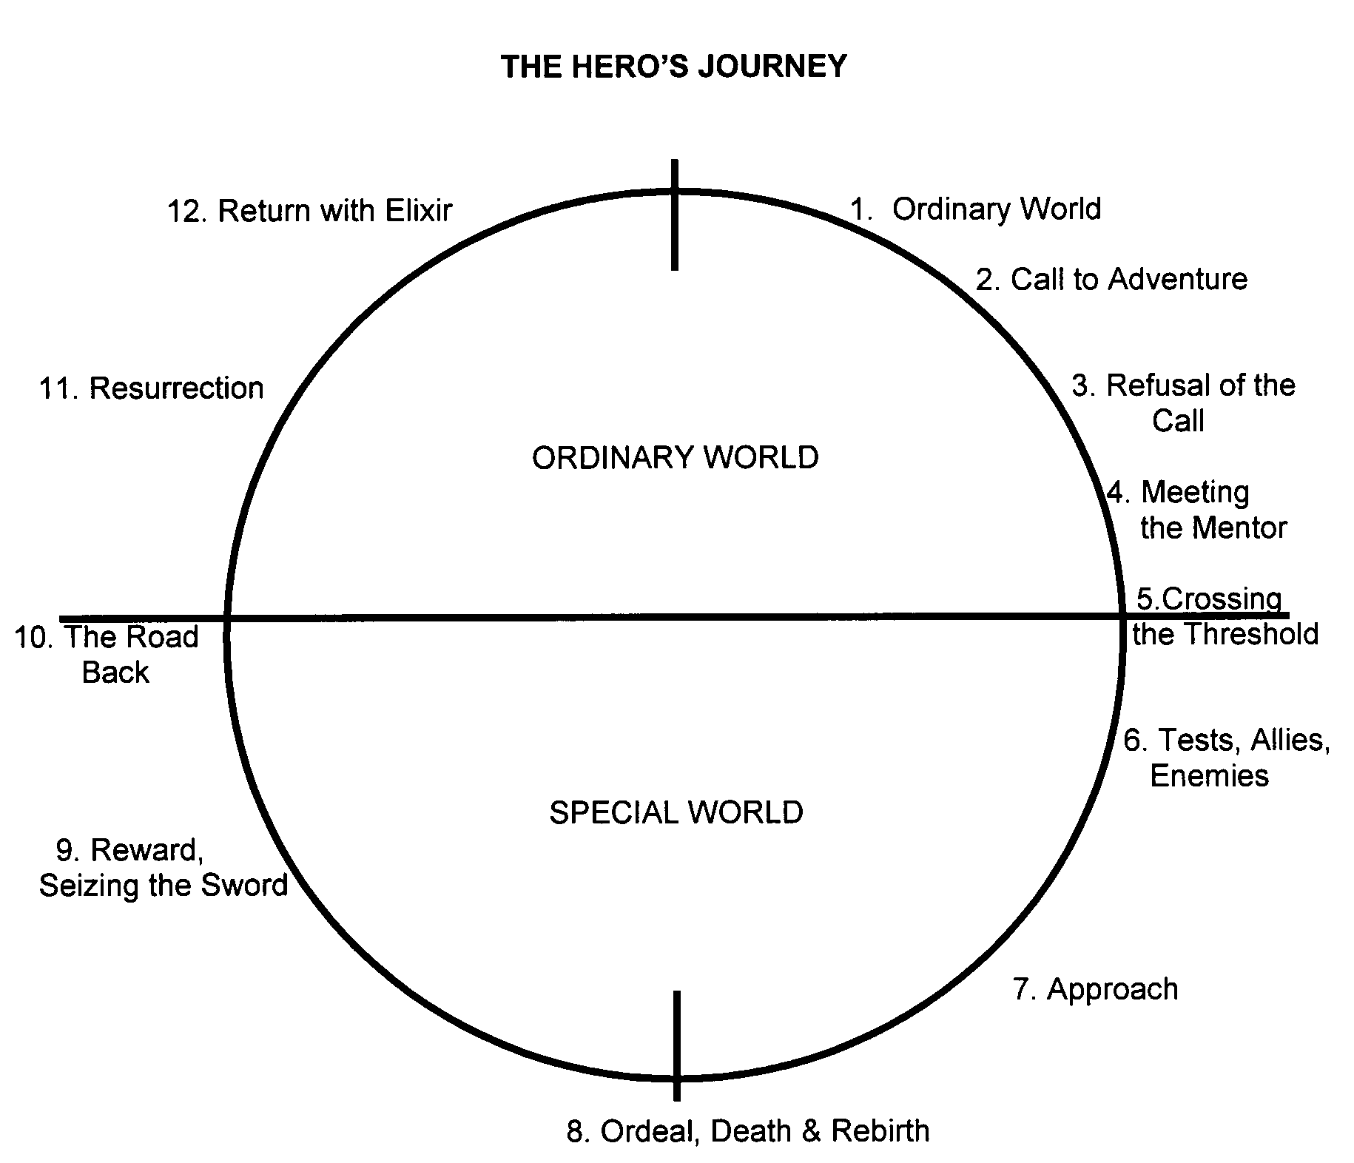
With some there may be a refusal of the call and the need for a mentor. We don’t have that recorded in Jesus’ narrative. But then there comes a point when the questing hero crosses the threshold into the special world of the quest – for Jesus, his baptism in the Jordan – then immediately the hero encounters tests and enemies and finds allies. The test is Jesus being tempted through his inner fears, the enemy is portrayed large as life as the devil and his ally is the scripture he learned in Hebrew school.

Someone writing this story to Jesus’ followers decades later knew that the true hero whom Jesus had turned out to be, would have encountered and most importantly overcome tests and trials at the beginning in order to succeed later, hence this story.

A version of this hero’s journey is asked for from the heroes and heroines in this room, from you and from me. We are being called to that journey in new ways all the time. Even if our questioning has had us decide that this devil isn’t real and this conversation never happened just like this, this does not mean that the challenge to go on the quest for wholeness and individuation is still not being posed to us, right here right now in 2017. In a way, the arrival of the Trump administration into our world is a renewed call to the quest for a just and peaceful world. It is showing us new temptations inside us – the temptation to not bother, to hope it will all go away, or to obsess about Trump and ignore what needs doing here in NZ and miss out on the important issues for our own elections this year. The Pride Festival this week reminds us of the work still needing to be done to combat homophobia in general and to protect and enforce human rights for the transgendered community in particular. Come along on March 9th and 16th to get educated about that area of our society. This story is not a fairy tale about a deluded ancient preacher, it is a story we could enact today in a different time, a different place and different temptations.

I sometimes wonder when we hear a clear rational description of the world and scripture and the church from an intellectual mind like Lloyd’s whether mentally we are tempted to sit back, to assume, with relief, that we don’t have to bother any more with all the funny supernatural embarrassing things in Scripture like Jesus talking to a devil in the middle of a desert. That we can brush aside Psalm 32 and others like it. Let me read you a version of Psalm 32 which I think could be written by a stage four faith person. You can compare it with the original at home. Even this 21st century version implies there is still personal spiritual work to be done.

Psalm 32 for Stage Four Pilgrims
Anyone forgiven for how they have stuffed up, is at peace.
Those who find wrong doing is not counted against them find serenity.
Integrity too brings great calmness of spirit.

When I refused to admit responsibility for what I had done wrong
or for the good I had not done, I got really depressed.
For a long time, day and night, I felt weak and apathetic.

Then I took responsibility and did not hide from being accountable
I admitted what I had done wrong to myself and others.
I then found I could forgive myself and that helped others to forgive me too.

So I hope everyone will do that. If they can find the same peace I did,
they might stop feeling they are drowning in their own rough, dark sea.

I have discovered a quiet, peaceful place deep within me where I can hide.
There I am protected from trouble and my heart sings with joy.
As I spend time contemplating and looking within,
it is as if I am taught how I should go;
It is like I am being counselled with love.

I don’t want to be like a mule, with no insight,
who has to be controlled by bit and bridle.
I realise now in the times when I only do wrong, lots of things go wrong,
but when I trust the pathway and follow the quest,
tapping into the stream of myth flowing beneath all our lives as a living dream,
unfailing love surrounds me.

This makes me glad. Let’s sing everyone! Sing for the joy of living!

Susan Jones 027 321 4870 04 909 9612 minister@standrews.org.nz

www.thewritersjourney.com/hero's_journey.htm

