Spirituality Blog (1) Holy Saturday 2017
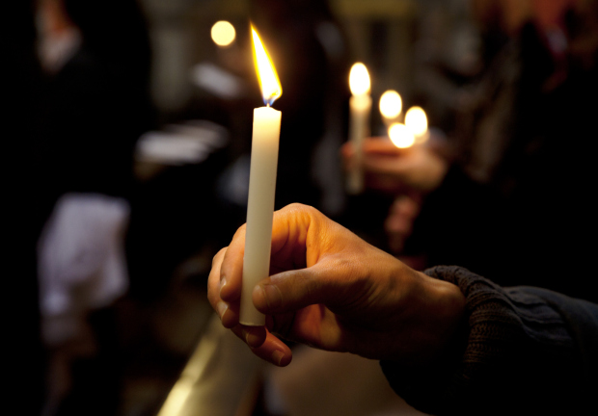
Easter Saturday is a good day to start a spirituality blog. For all the drama of Good Friday and the celebratory joy of Sunday, I think Easter Saturday is under rated.
True, we do well to acknowledge the horror of death on Friday. In our own lives we find it difficult to let go – especially something which has meant a lot to us. Life meant a lot to Jesus and to lay that life down because others objected to his message must have been painful, not only because it involved actual physical wounds. We know things and people and attitudes get in the way of us progressing at times. These things we have to ‘die to’. I remember hearing a female tele-evangelist telling of an impulse to give a friend some ear rings, then noticing that as she was sorting through and through her supply of ear rings she was finding it hard to choose one set to give away (She does wear rather special ear rings!). She caught herself at it and told her audience she decided she had to ‘die to’ her ear rings, so she could break the attachment and give. At the time I found it a bit twee, but there was within her story the essence of Good Friday.
The seeming blank inactivity of Easter Saturday then follows. Traditionally this is the day when Jesus ‘descended into hell’. It is the time when the reality of death sinks in. Experiencing the tomb where our attachment to things is buried, is the time (sometimes a long time) when we need to form new habits. This is hard, harder than we think it will be at first. But, it is in the darkness of this moment, that we are transformed, changed, like that fat old caterpillar transforming into the butterfly. As a metaphor it is almost a cliché, but there is truth in that image. Too, it seems that there is more happening than the sum of the parts. We do some setting up of new habits and some setting aside of old habits, but if this is a truly spiritual transformation,. There is something over and above our effort which comes into play. The ‘inactivity’ of Easter Saturday is the darkness in which we are changed, despite ourselves. Do not be disheartened if nothing at first seems to be happening. There is a lot which needs to take place and it will take time – frequently more than only one day!
The first time we planted a swan plant and I was able to observe caterpillar cocoons on a daily basis I was amazed at the changes e taking place before my eyes. Complete body parts disappeared and reappeared as completely different body parts. Colours were changed as well as function and shape. What internal mechanism and signals were making this transformation take place?
All I can say this Easter Saturday is face the deaths you need to allow and trust the Spirit for the changes which will follow as you wait. Keep on with your spiritual disciplines, waiting, reading, meditating, praying, whatever is your spiritual style and joyfully anticipate that through the darkness a dawn will slowly or suddenly appear.
Susan Jones

